**Case Study**

Name: Gaurav Singh

Batch: Shell7-SK-23-B4

**Problem Statement-** Implementing a Seamless CI/CD Workflow for a Spring Boot Application using Azure Boards, Azure, Git, Maven, Docker, GitHub, GitHub Actions.

**Background**: Streamline Solutions Inc. is a dynamic technology company specializing in cutting-edge software solutions. The company is developing a sophisticated Java Spring Boot application designed to revolutionize user experience. To ensure a swift and error-free software deployment process, Streamline Solutions is seeking to establish an efficient Continuous Integration and Continuous Deployment (CI/CD) workflow.

Project Management Setup: - Laptop, Azure Login, GitHub Login

Azure VM Configuration:

Creating a virtual machine-

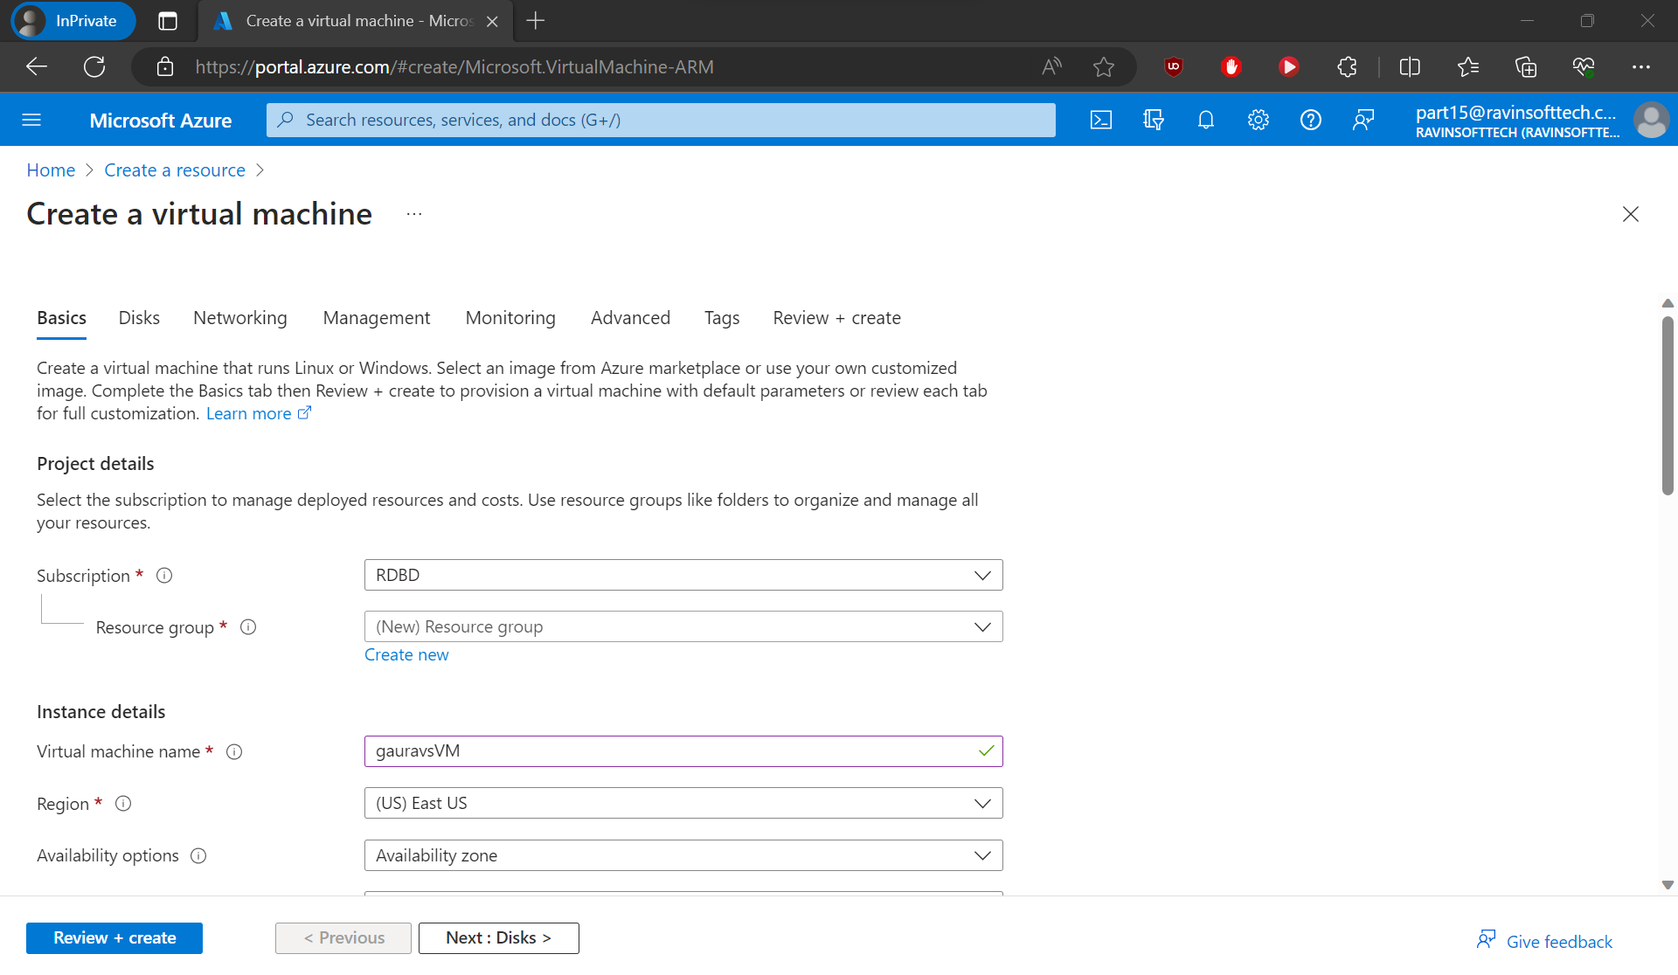

Enter username and password for the virtual machine-

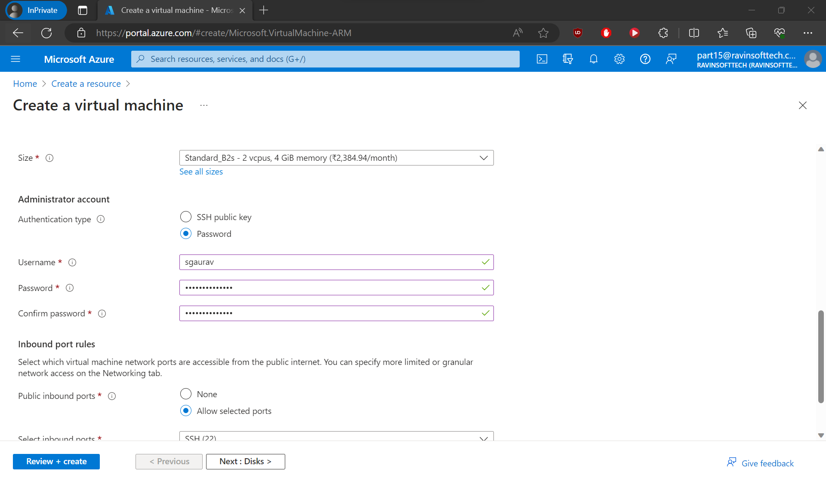

Entering the disk type and storage for the VM-

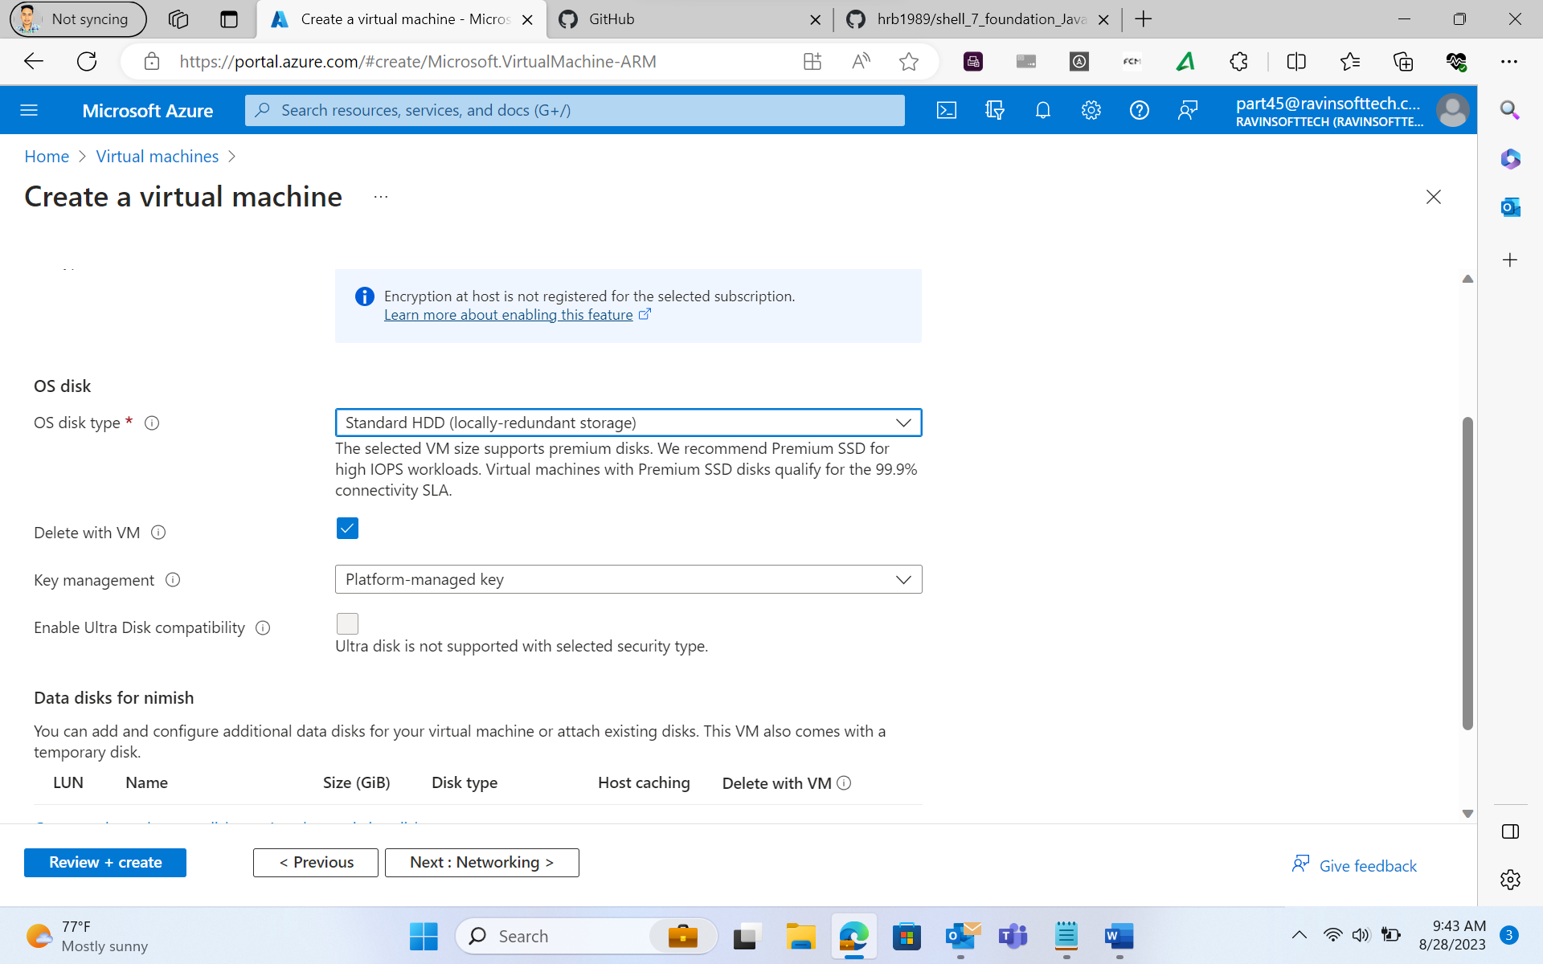

Validation passed-

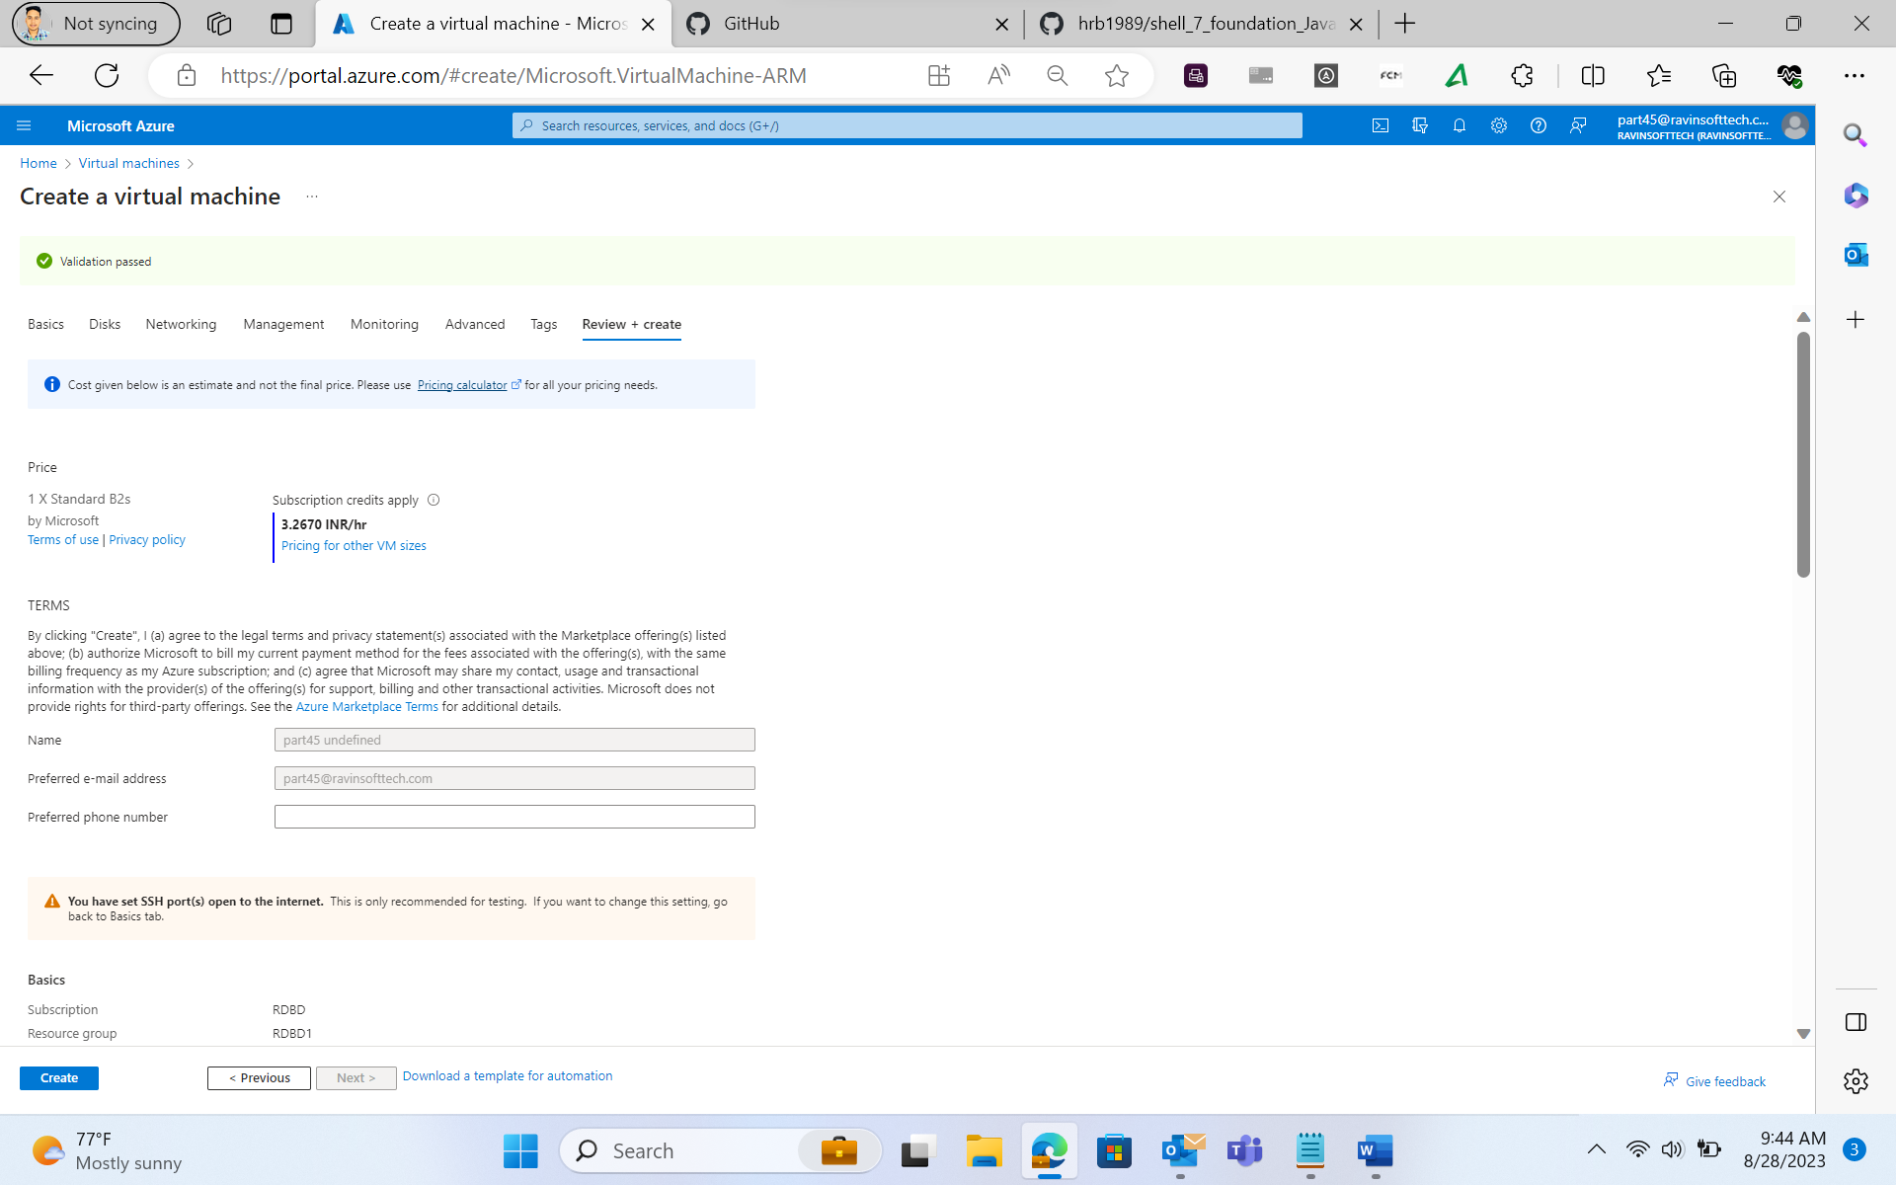

Completion of Deployment-

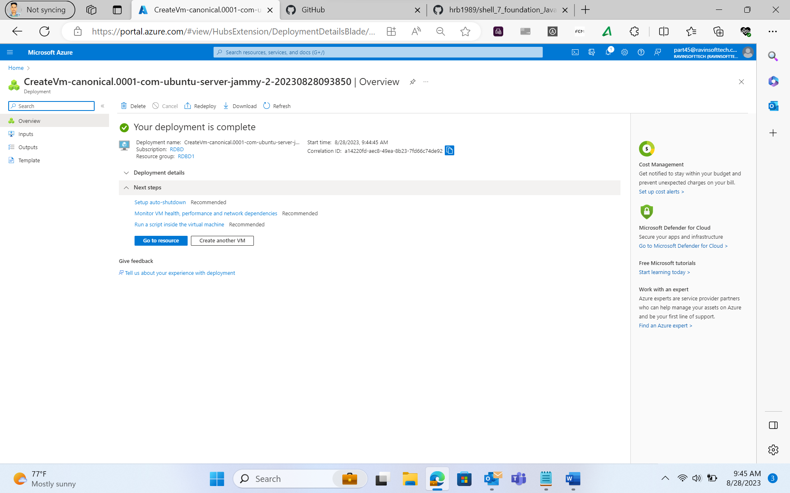

Overview of the Virtual Machine-

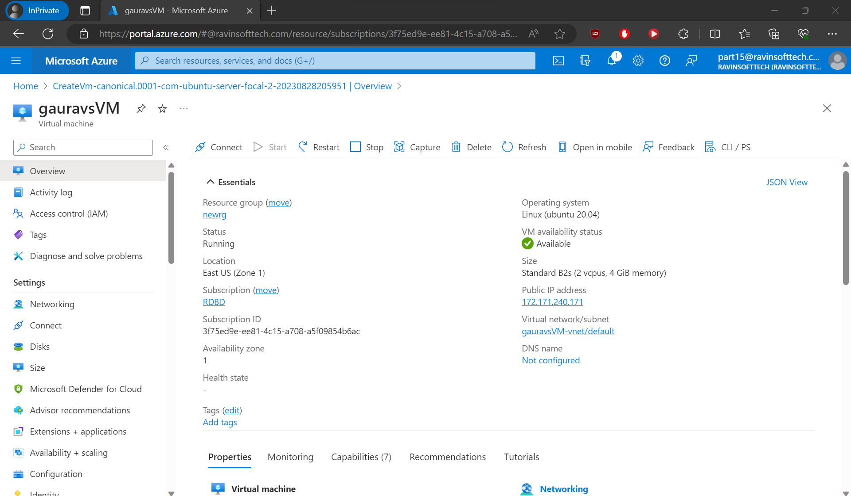

Maven-Based Build Process:

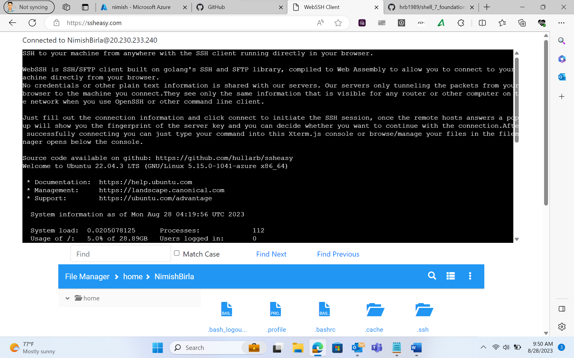

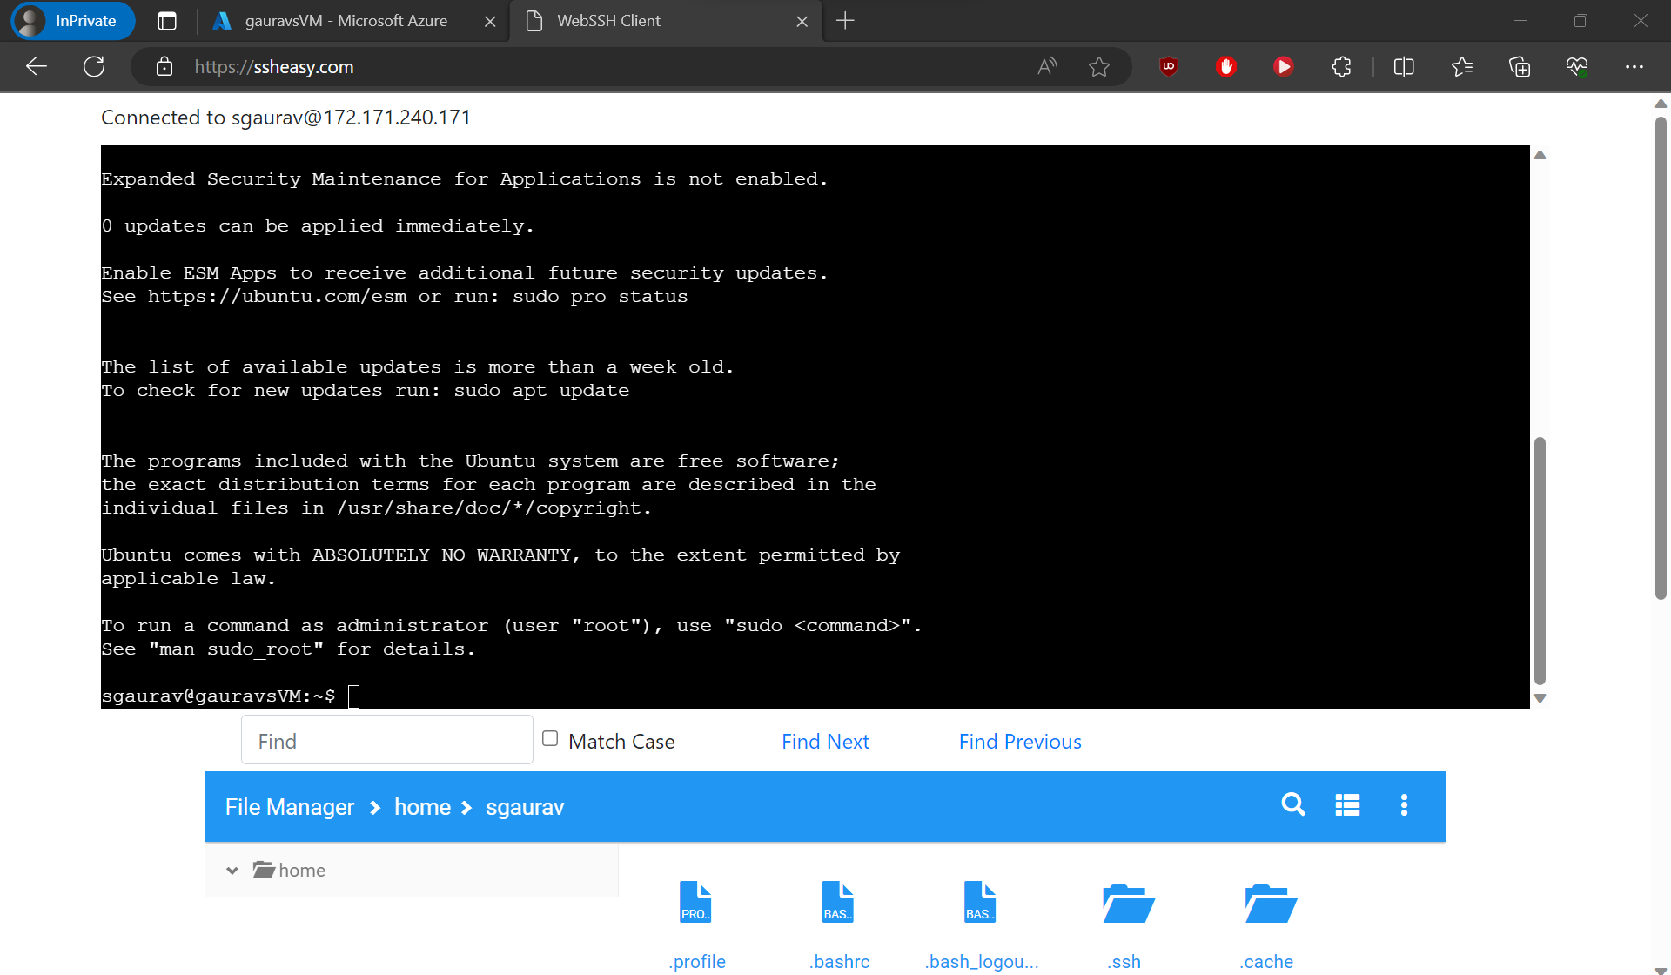

Updating the machine apt packages-

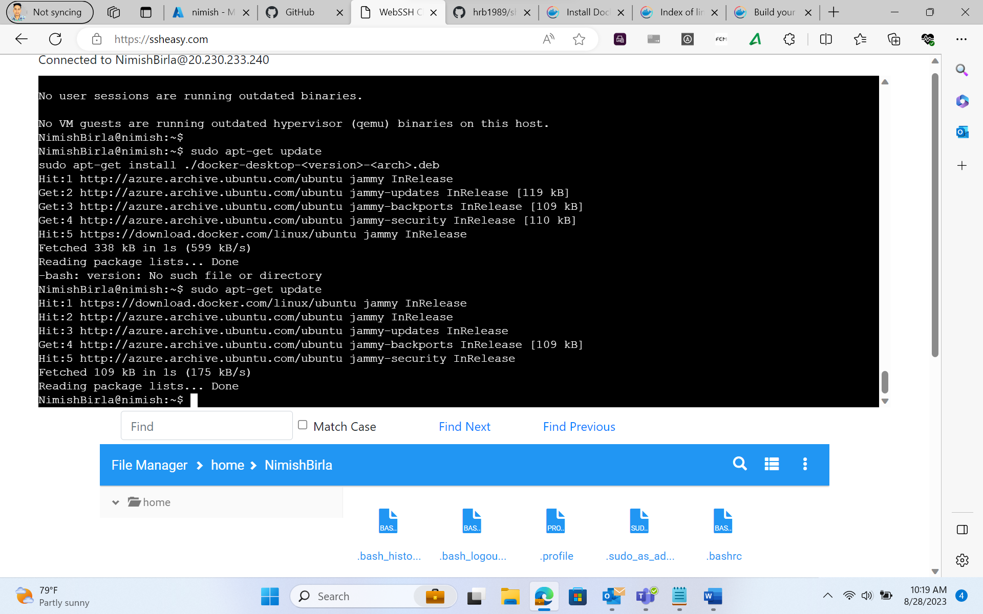

Installing the docker software-

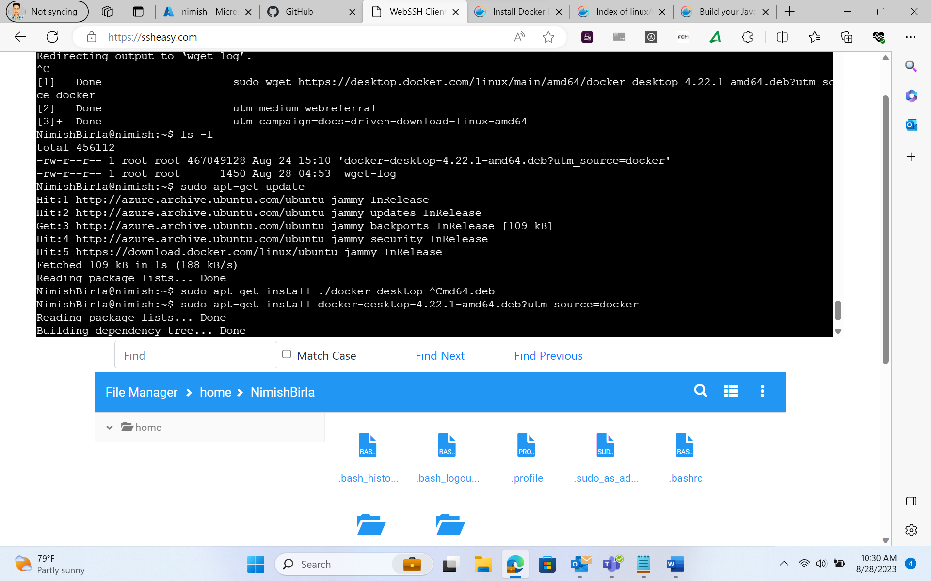

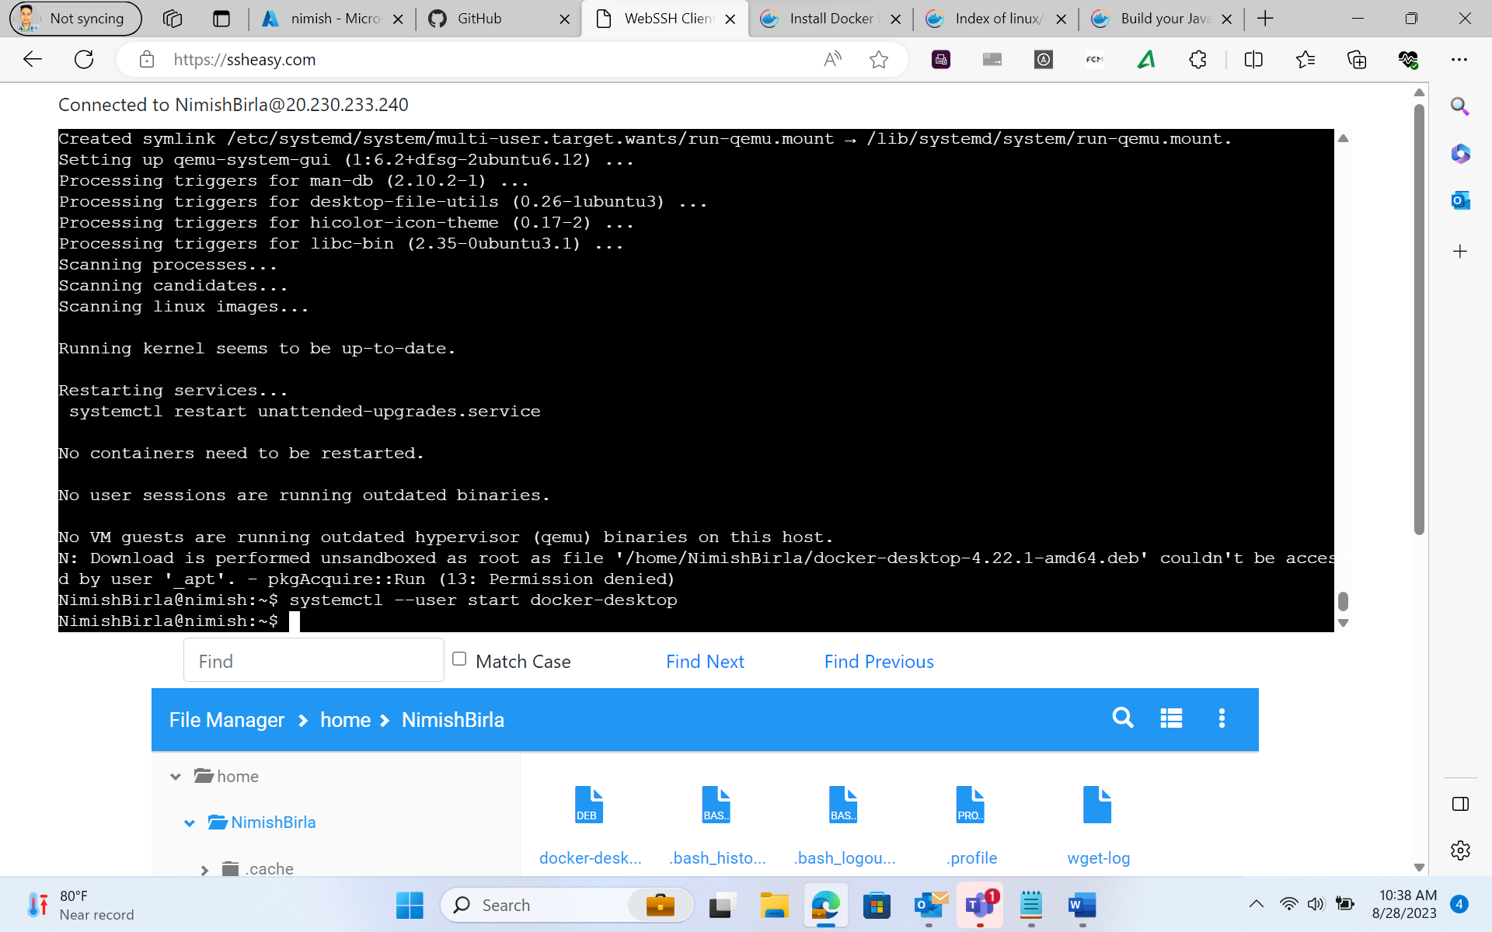

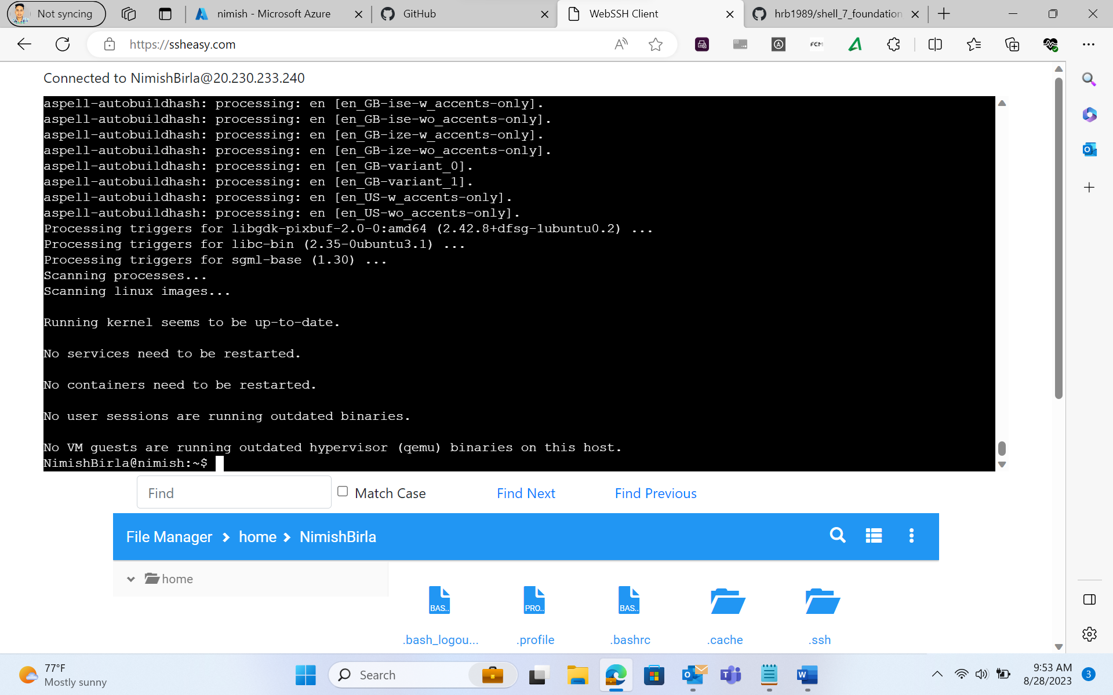

Docker Containerization:

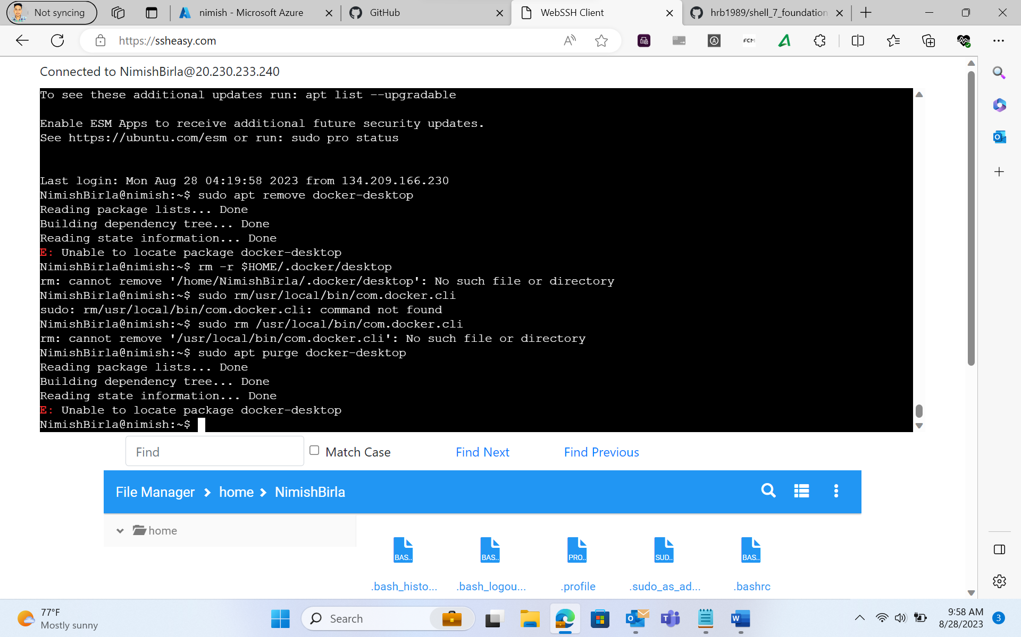

Showing the docker version-

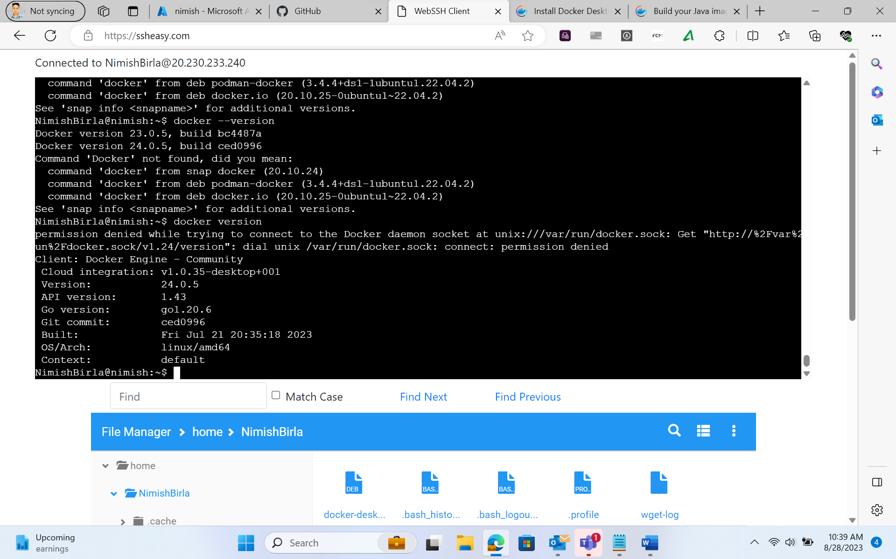

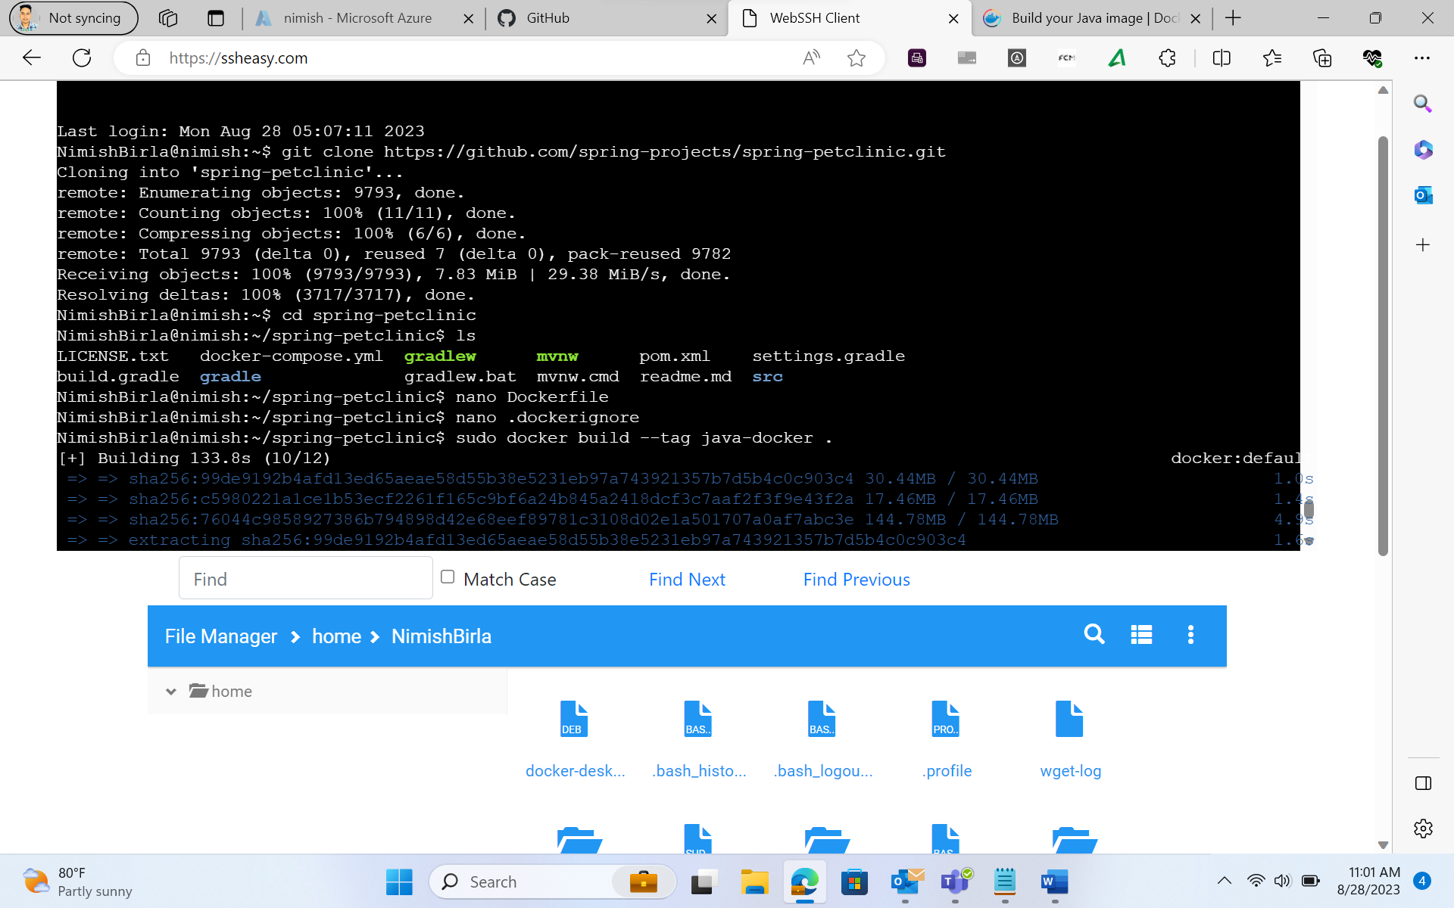

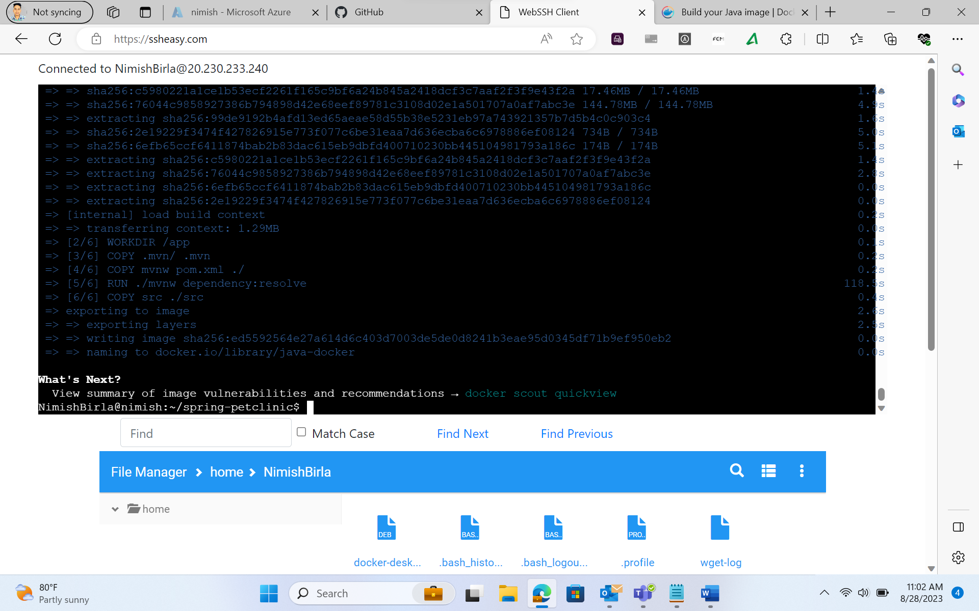

Azure Web App Configuration:

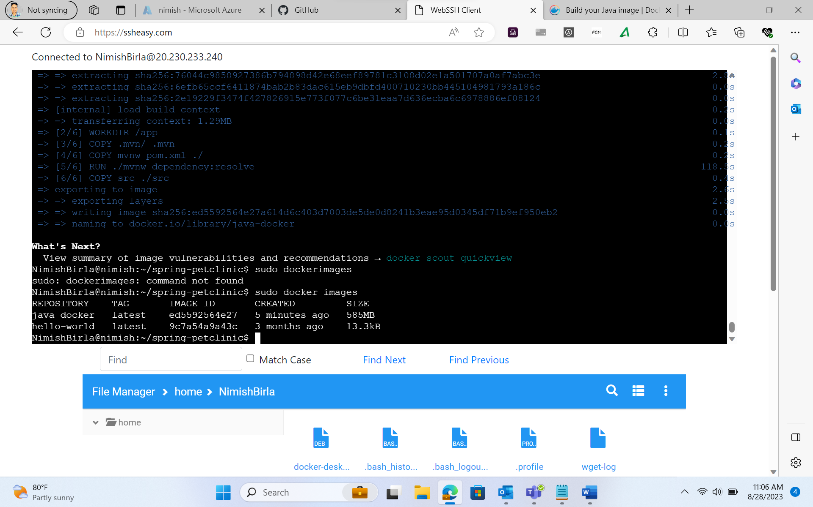

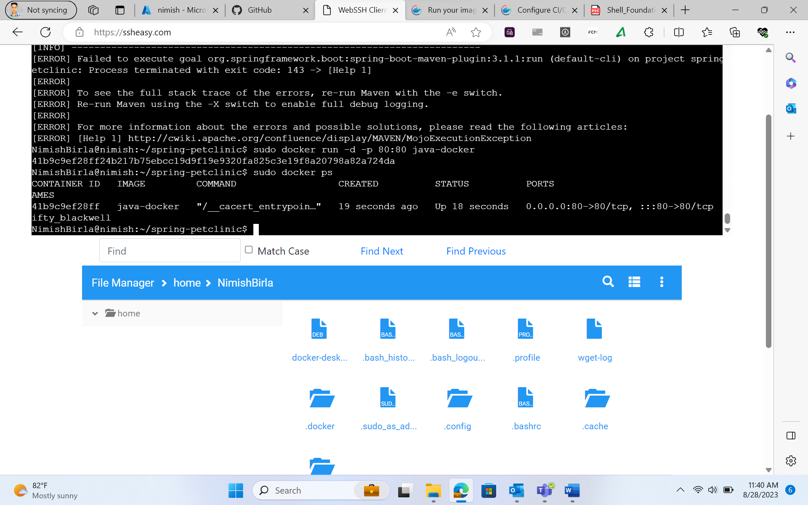

Pull Request Collaboration:

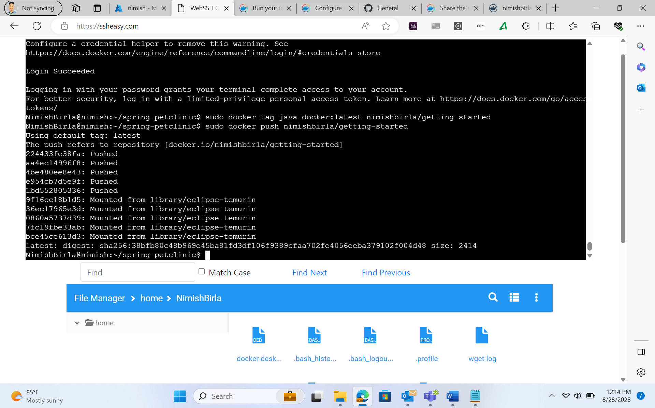

GitHub Actions Workflow Implementation:

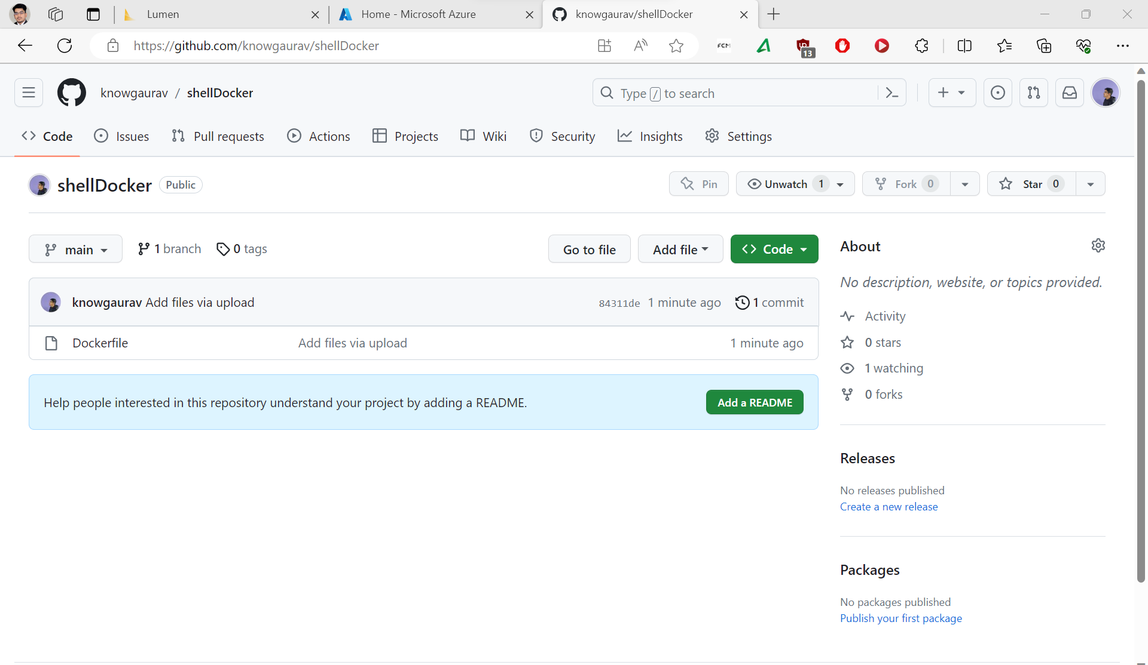

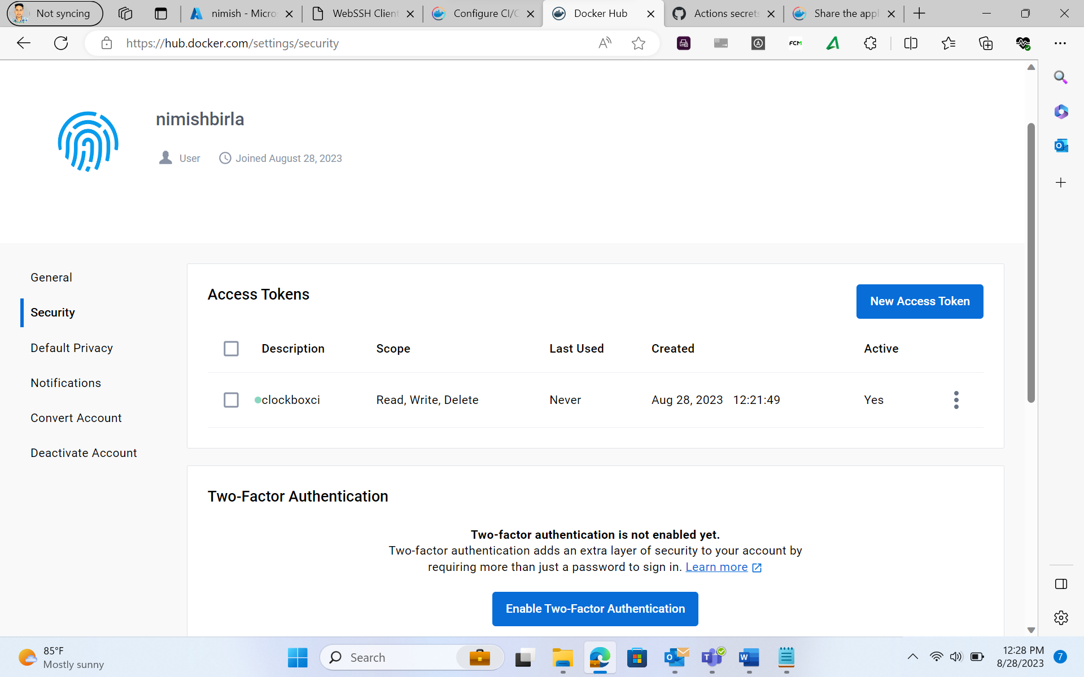

The main.yml file-

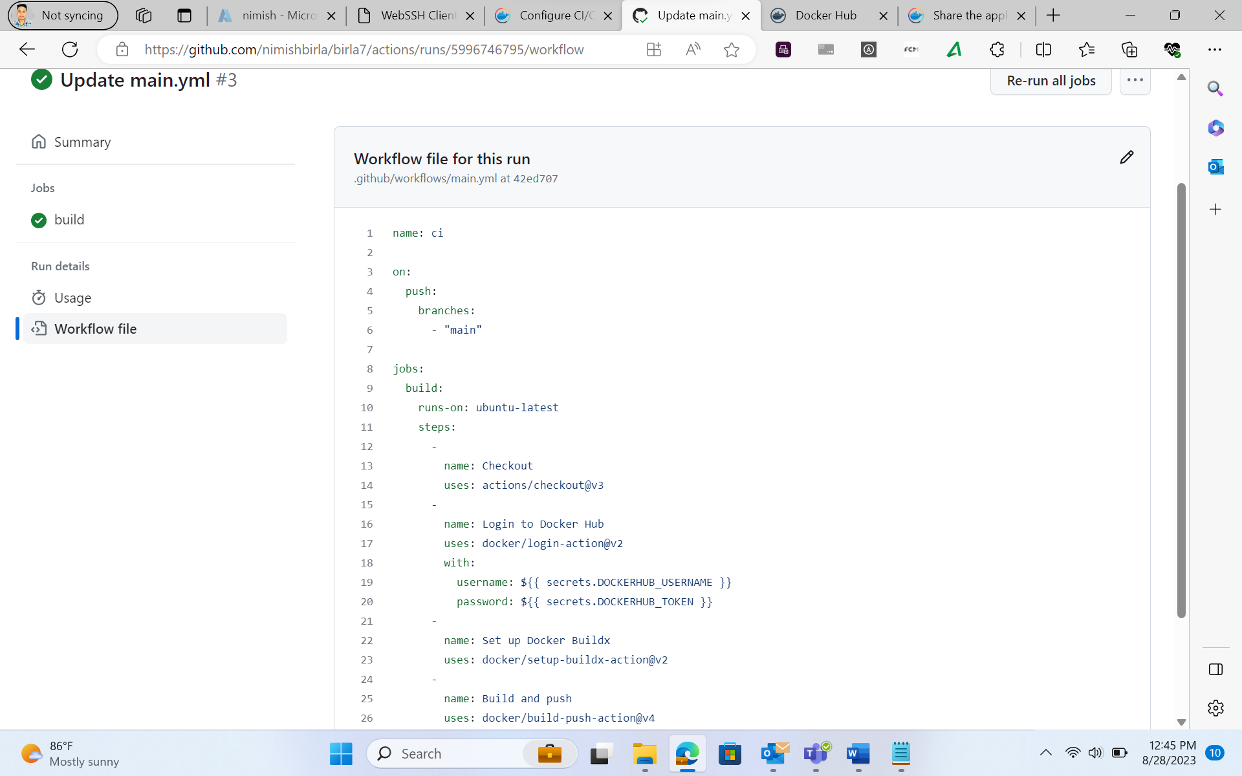

Successful build of the main.yml file-

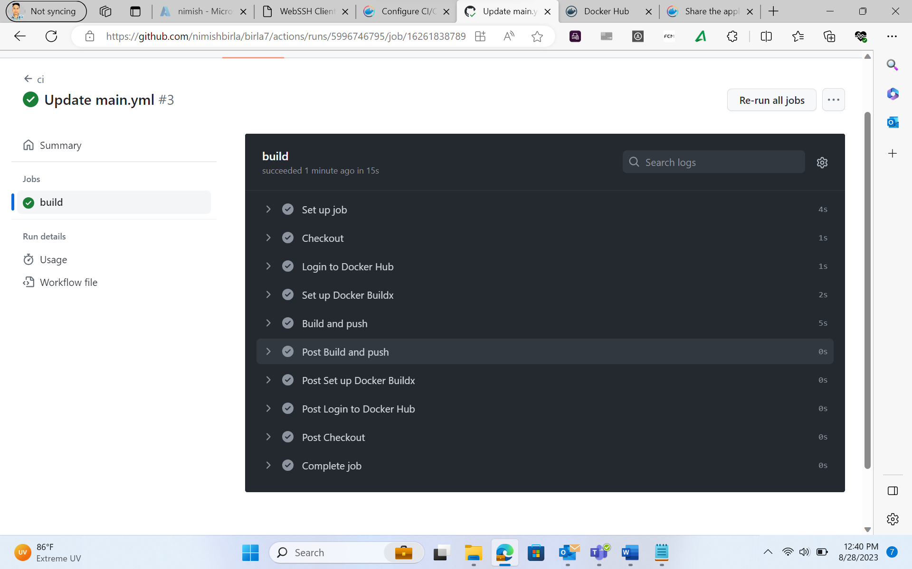

Local Testing of Azure Web App:

Azure Boards Task and Sprint Closure:

Outcome:

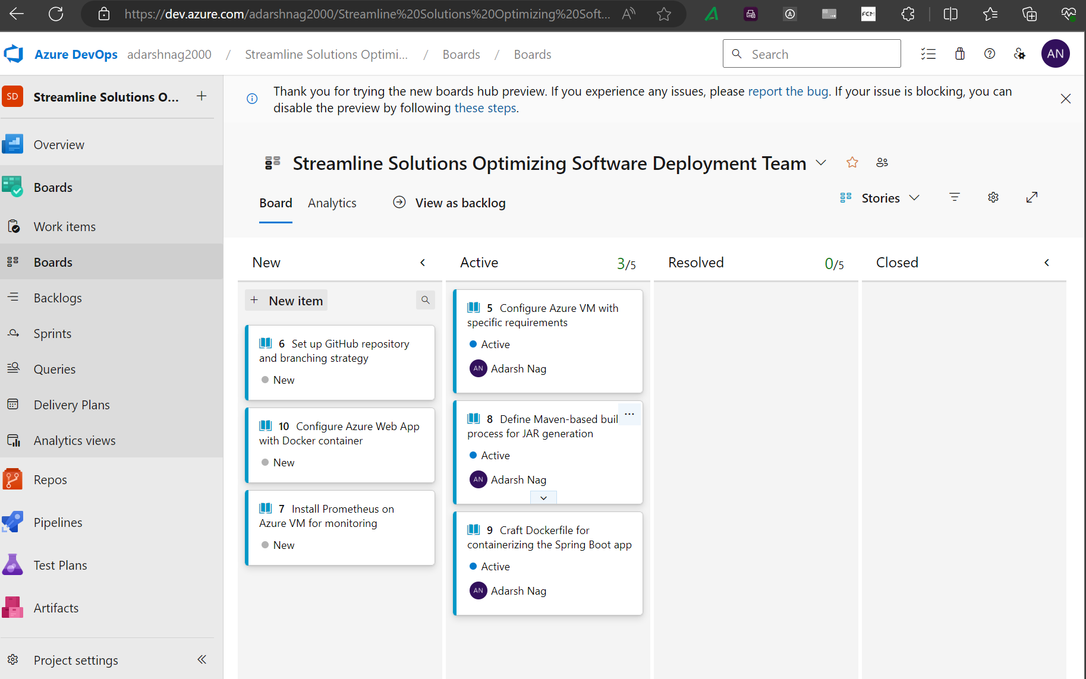

1. MVN clean command

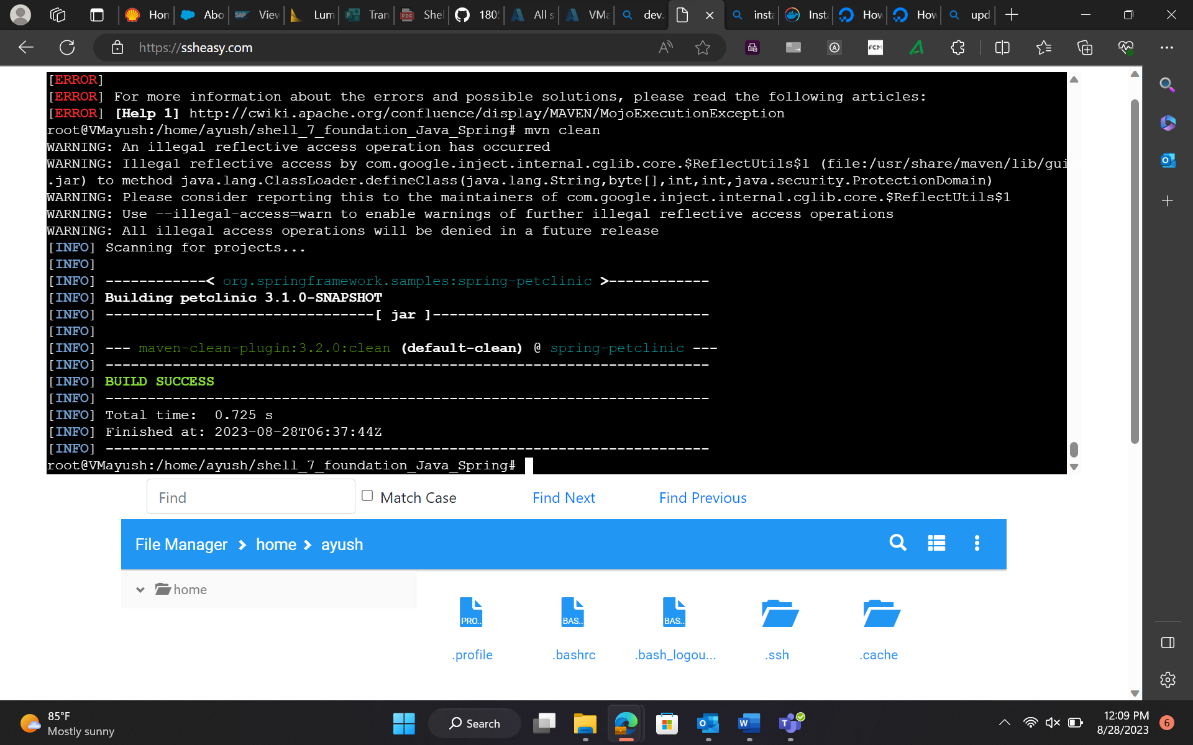

1. Run Maven commands to build the Spring Boot application:

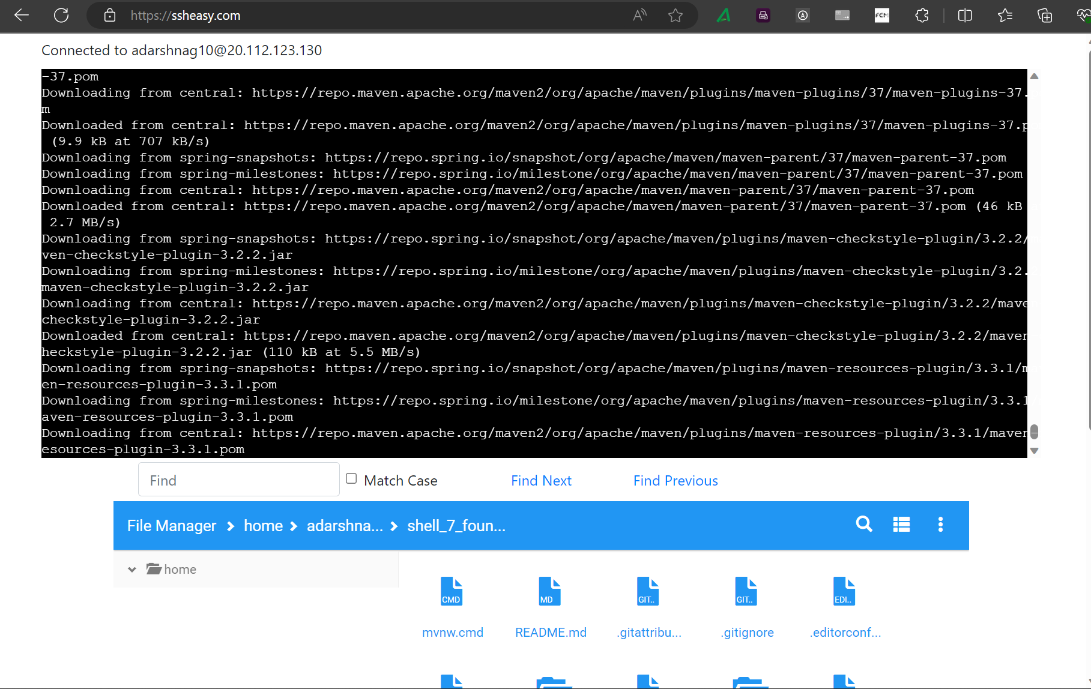

1. Build with Spring Boot:

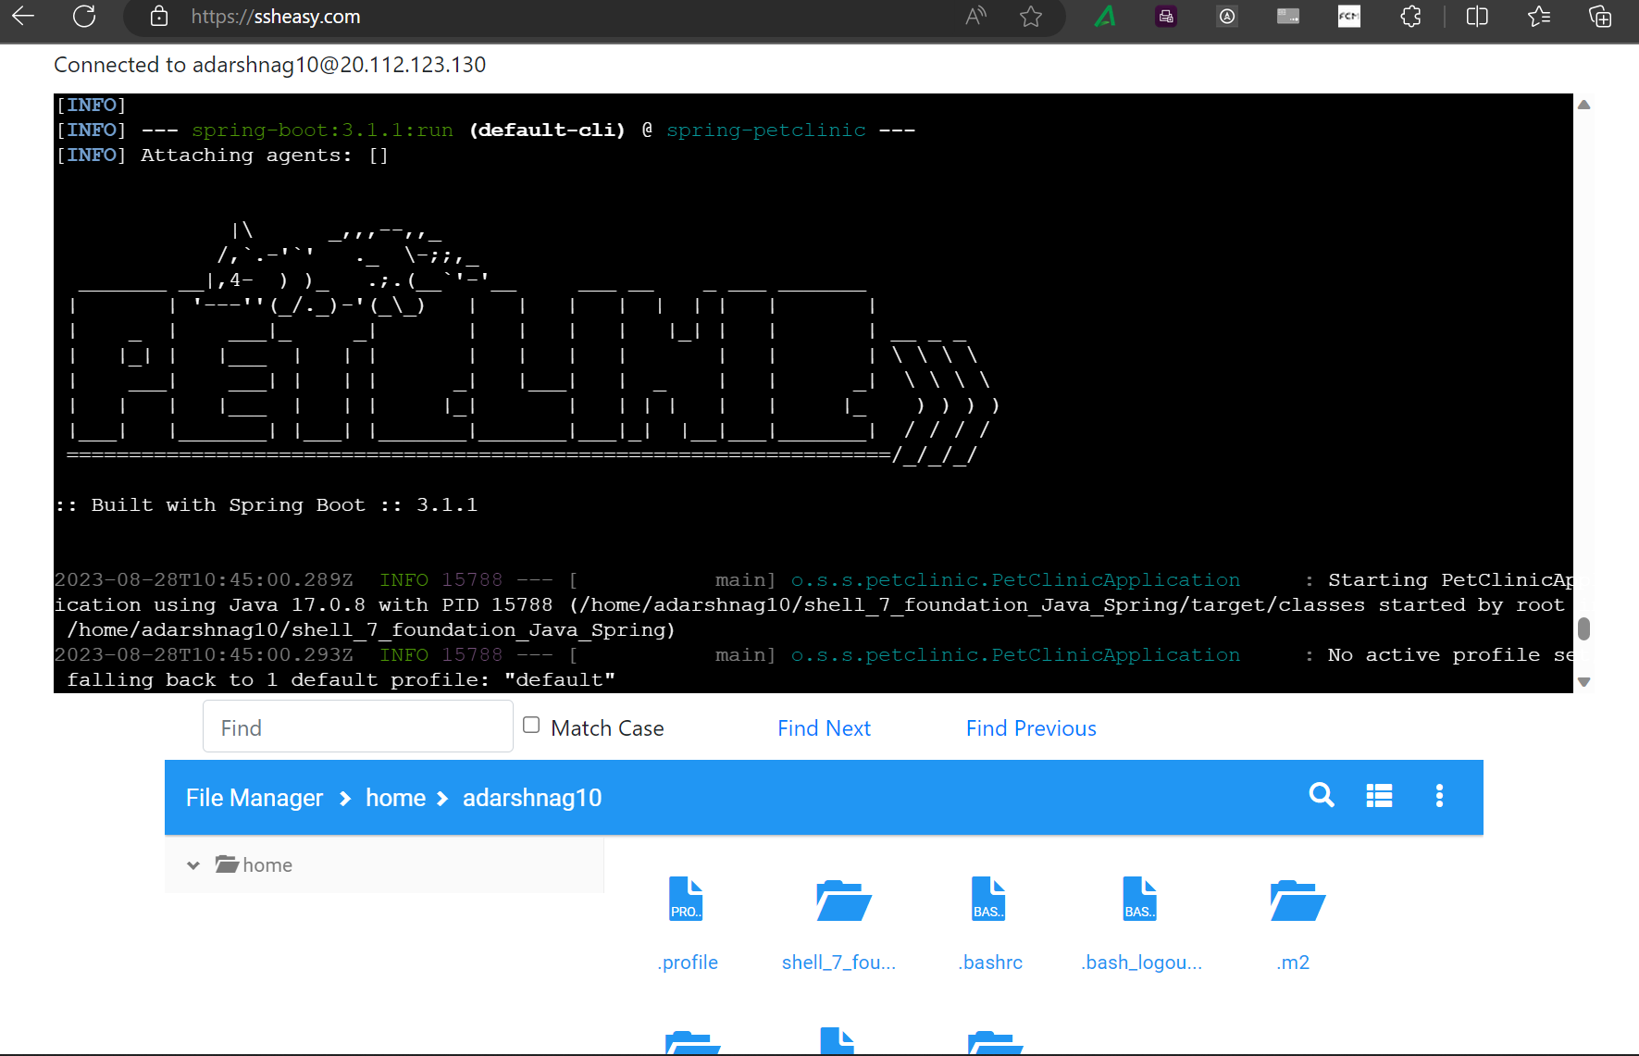

1. Execute JAR FIle:

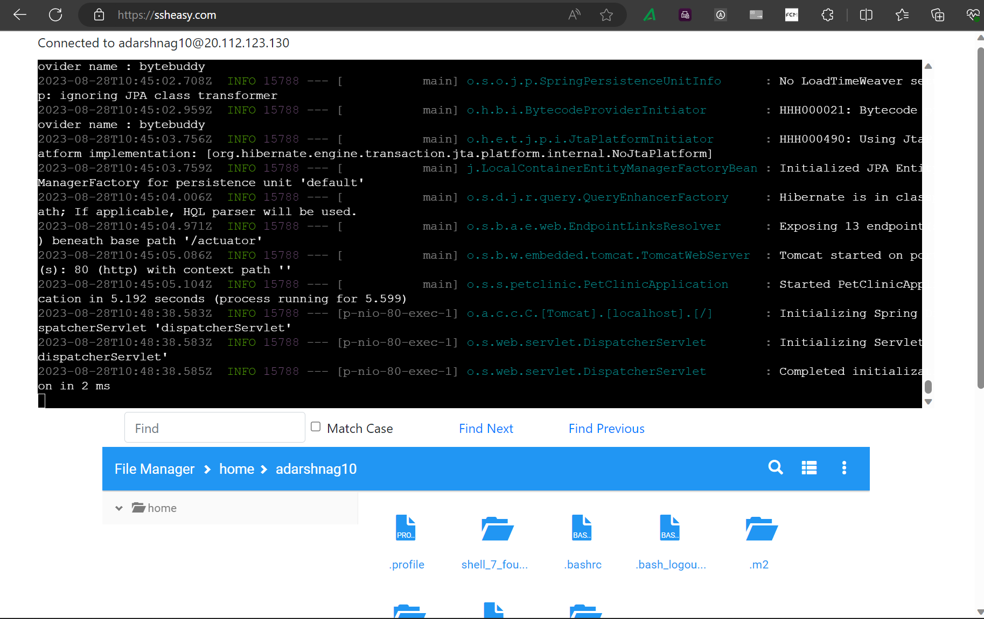

1. SpringBoot Application running

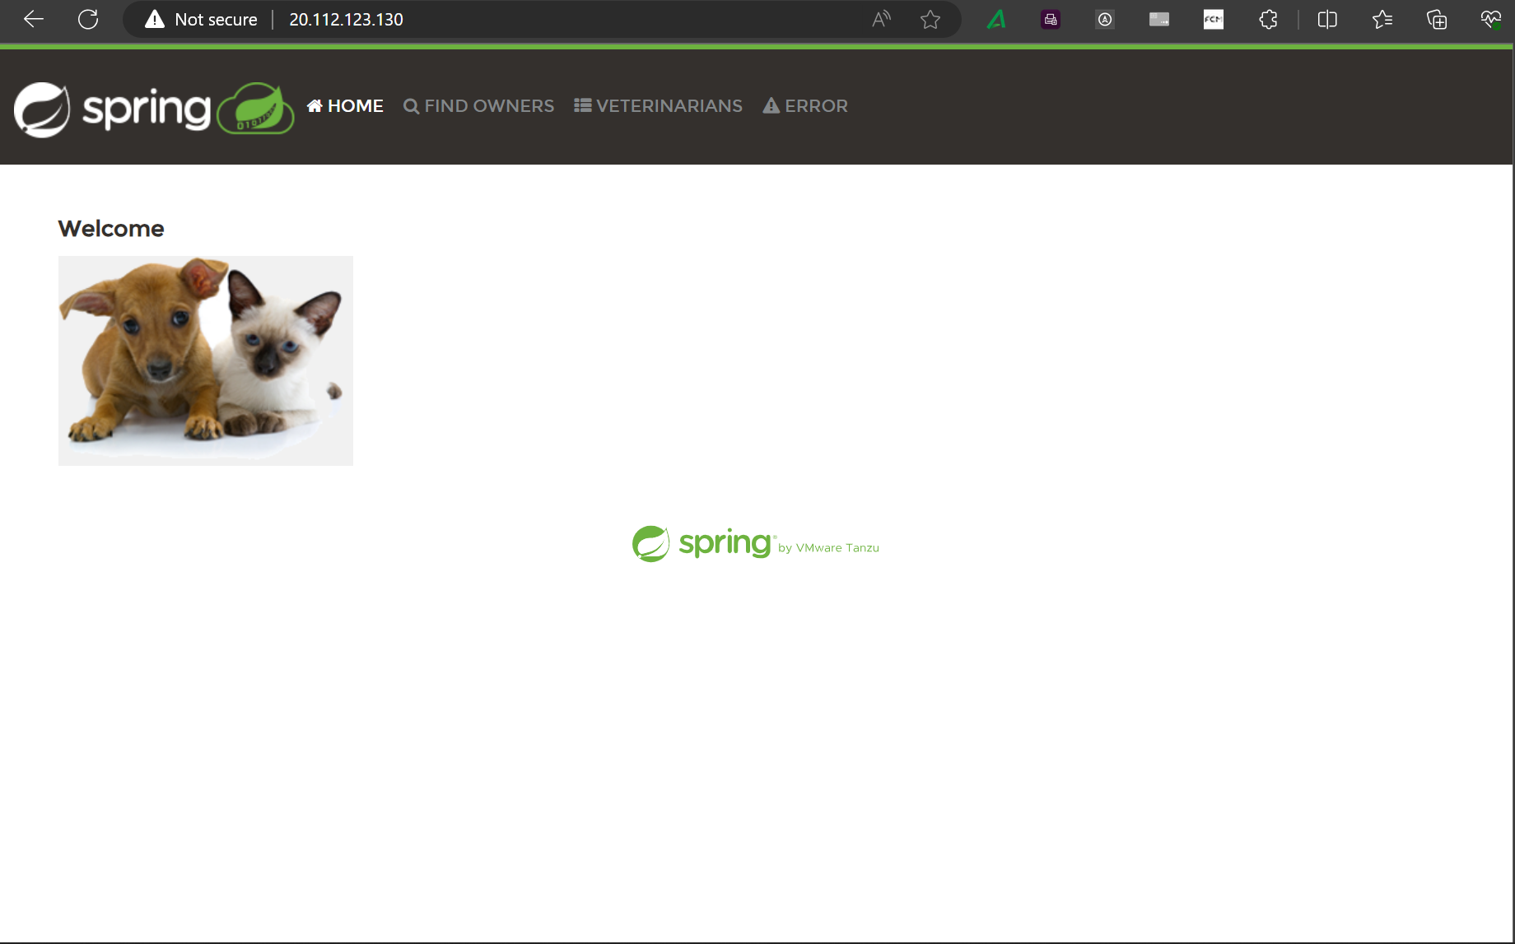

1. Create docker file

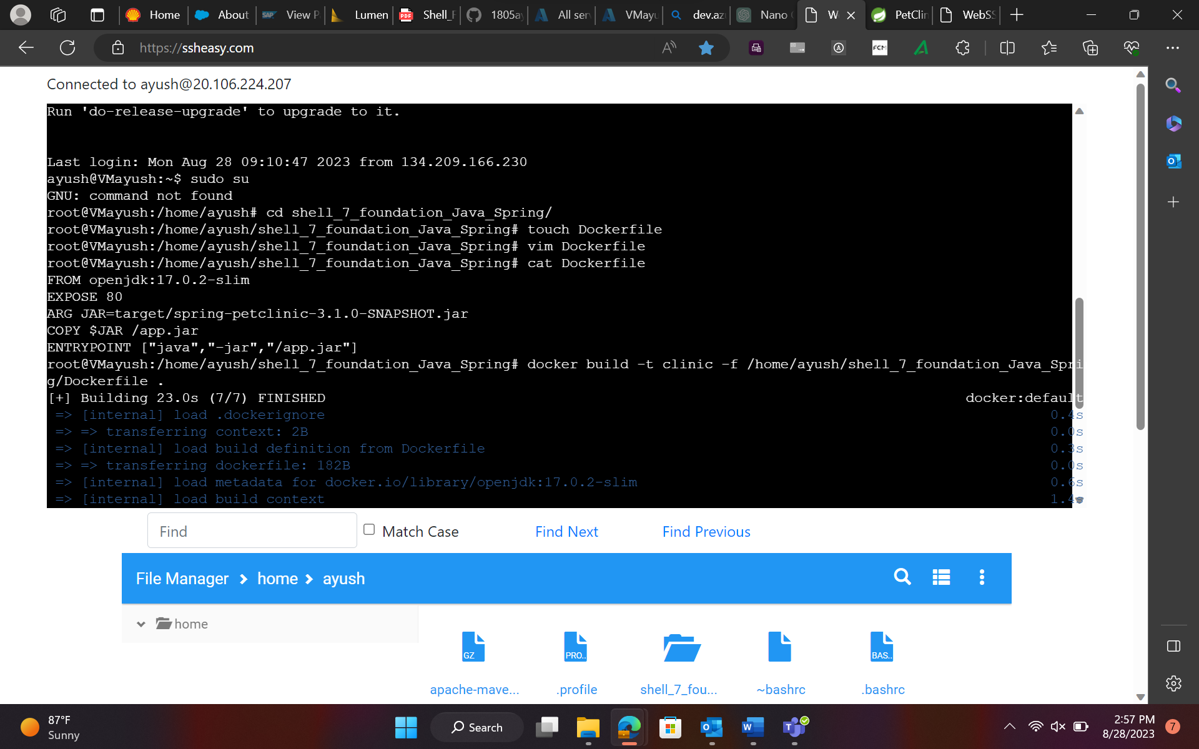

1. Login to Docker File

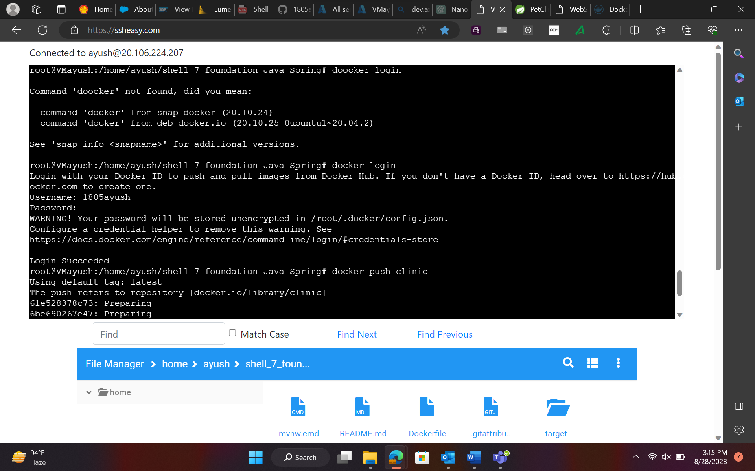

1. Push to Docker Repository

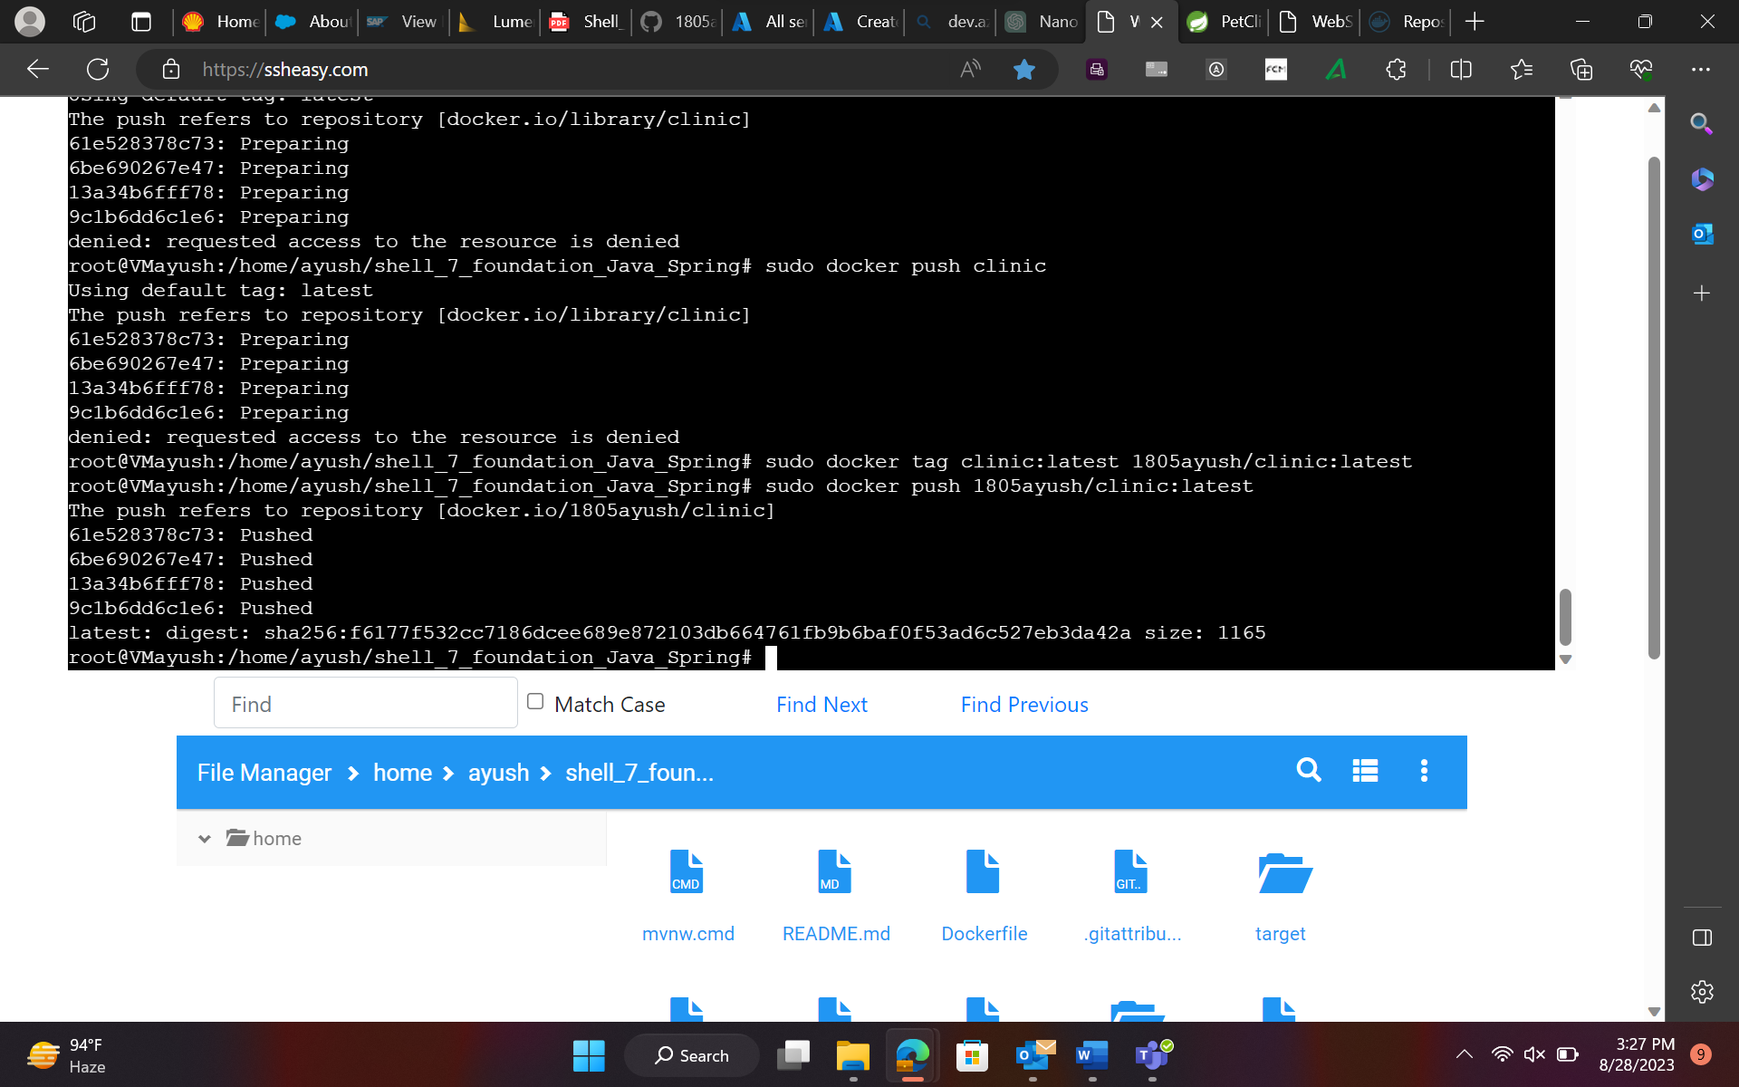

1. Create Azure Web App

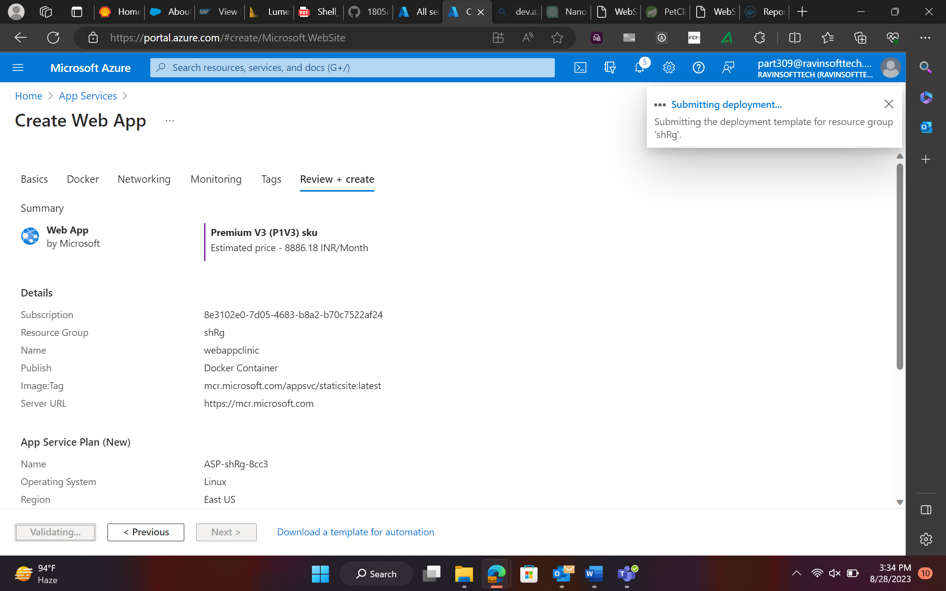

1. View Azure Web Apps:

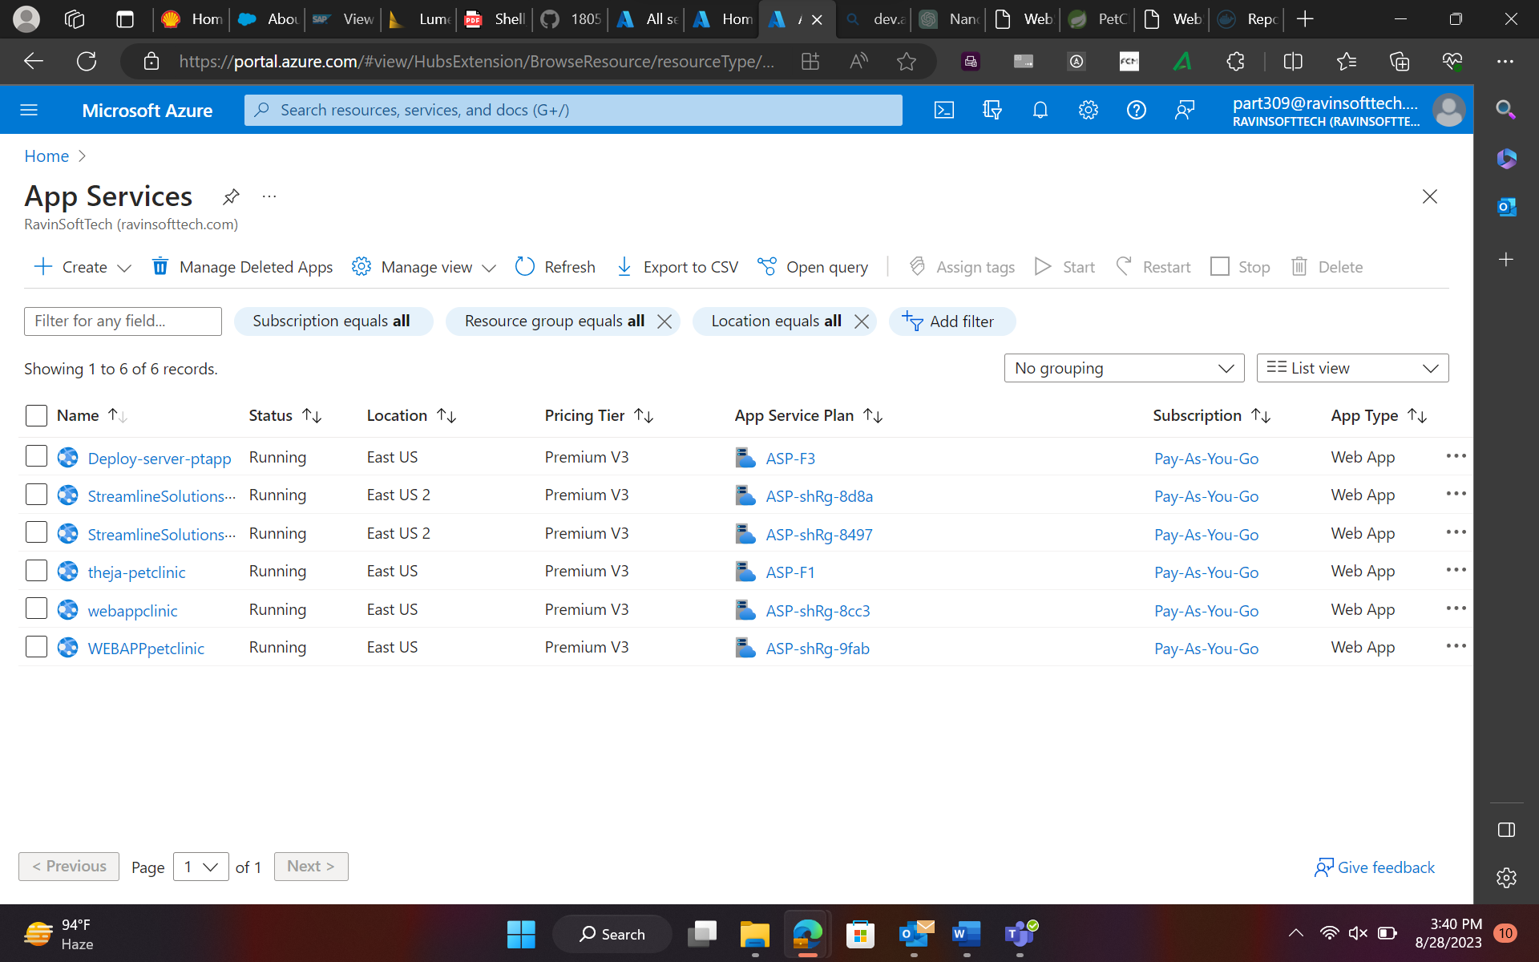

1. Deploy Web App on Azure:

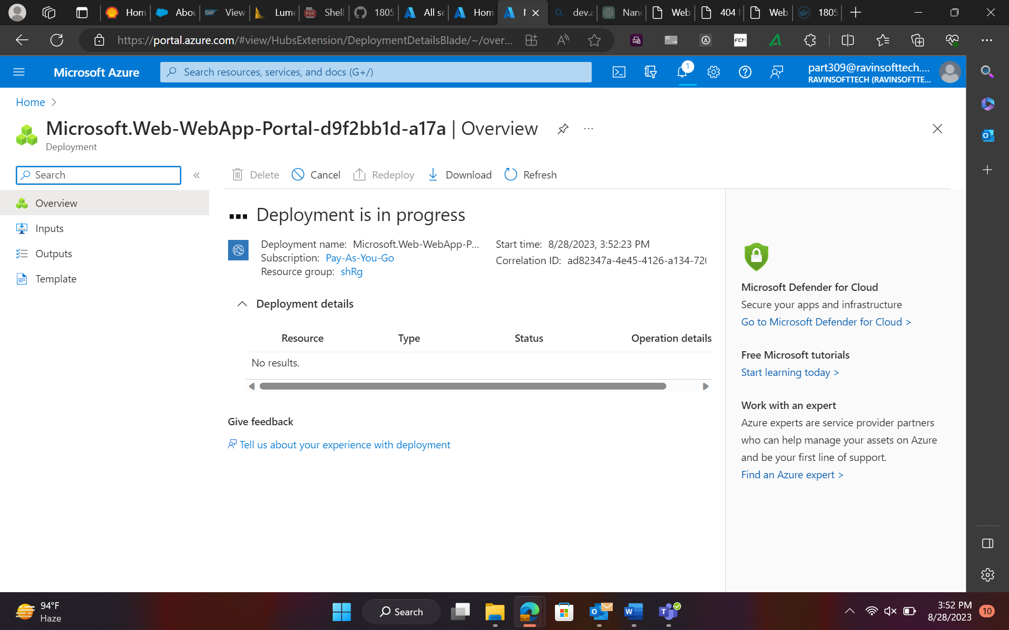

1. Prometheus

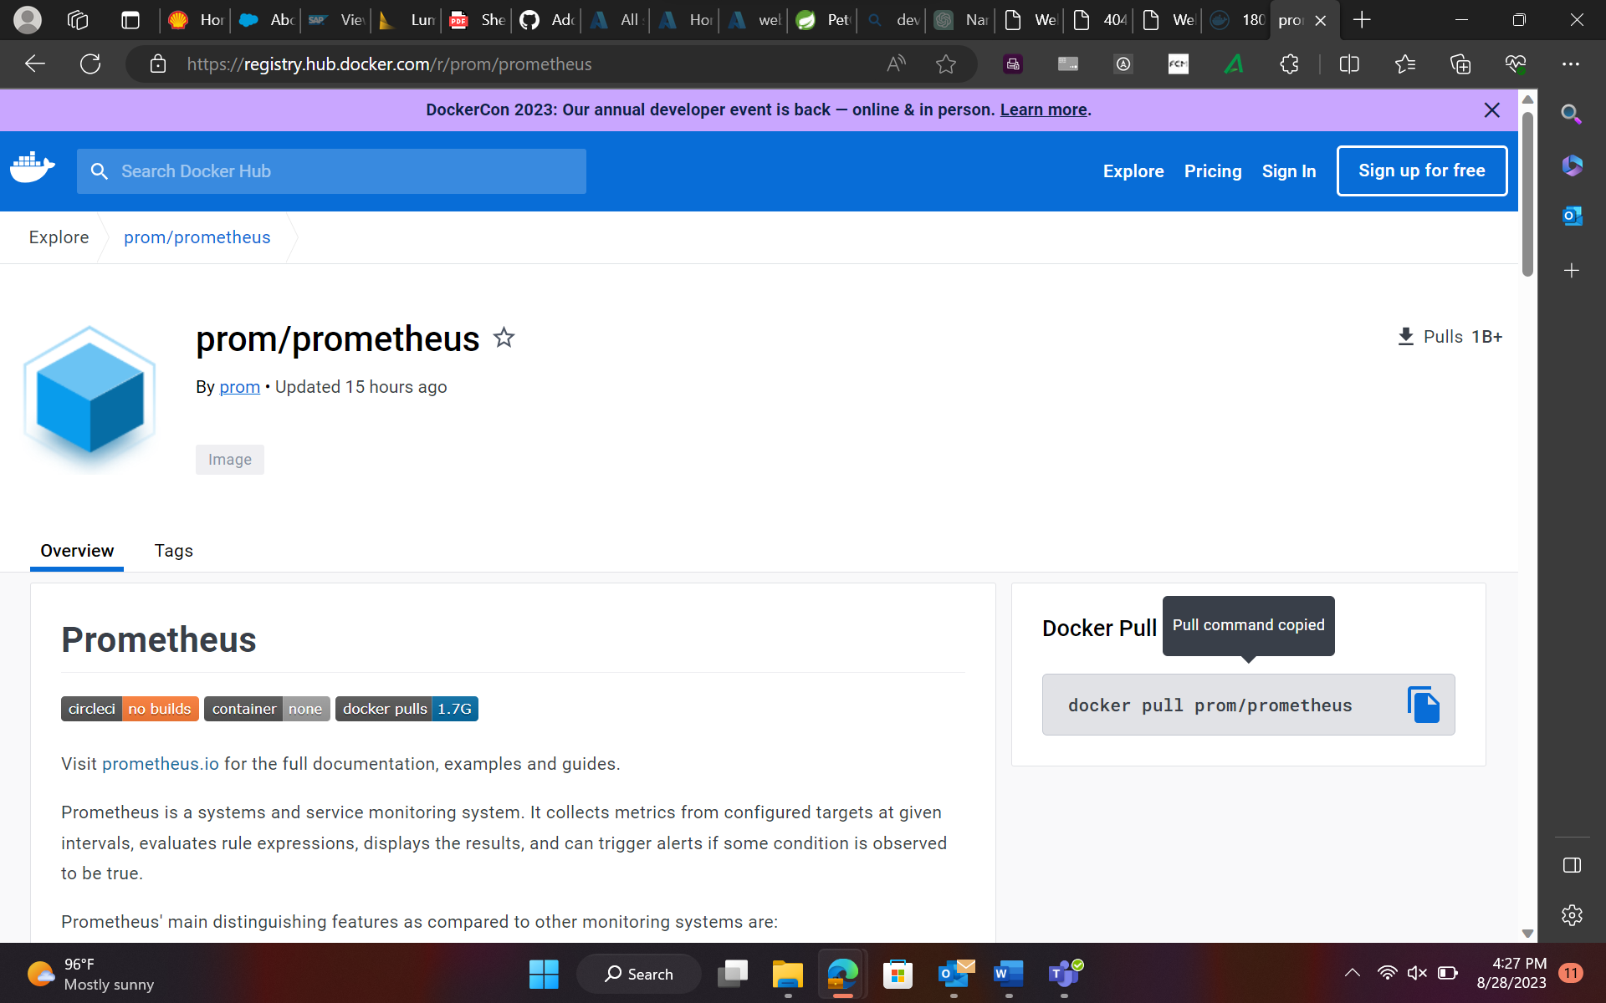

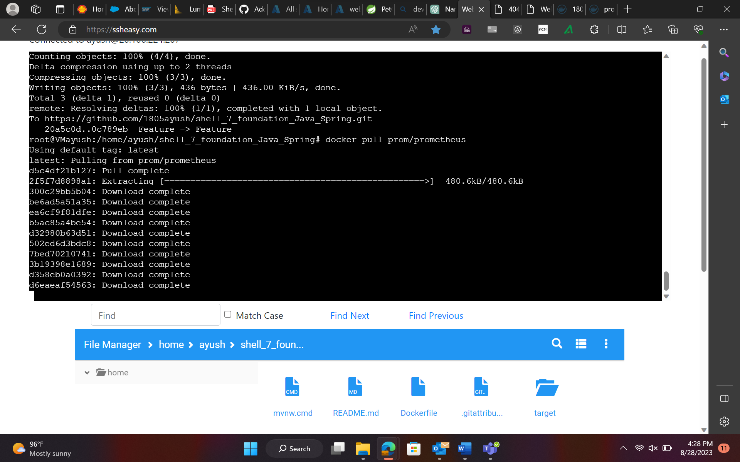

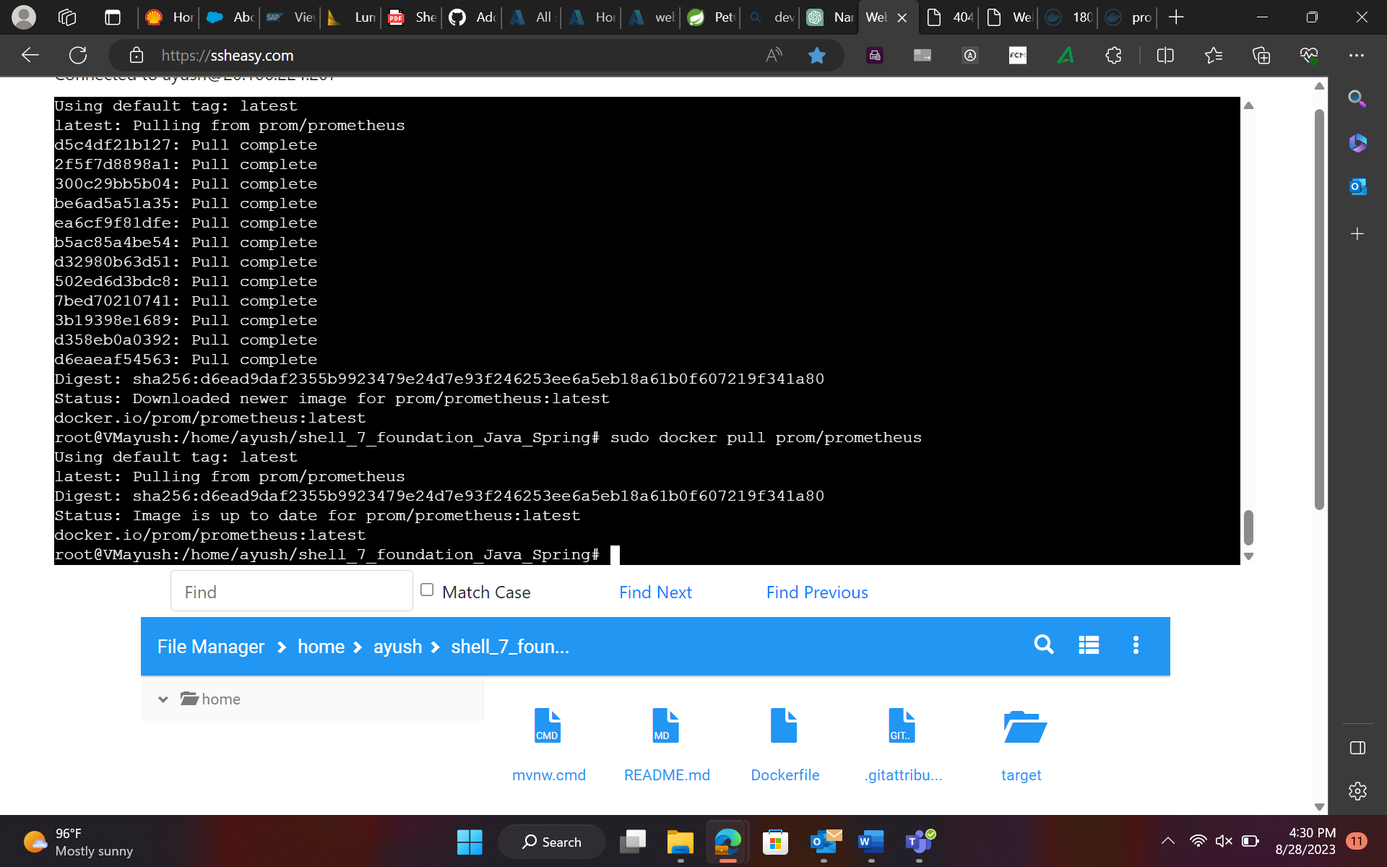

DevOps

Step1 : Creating a project

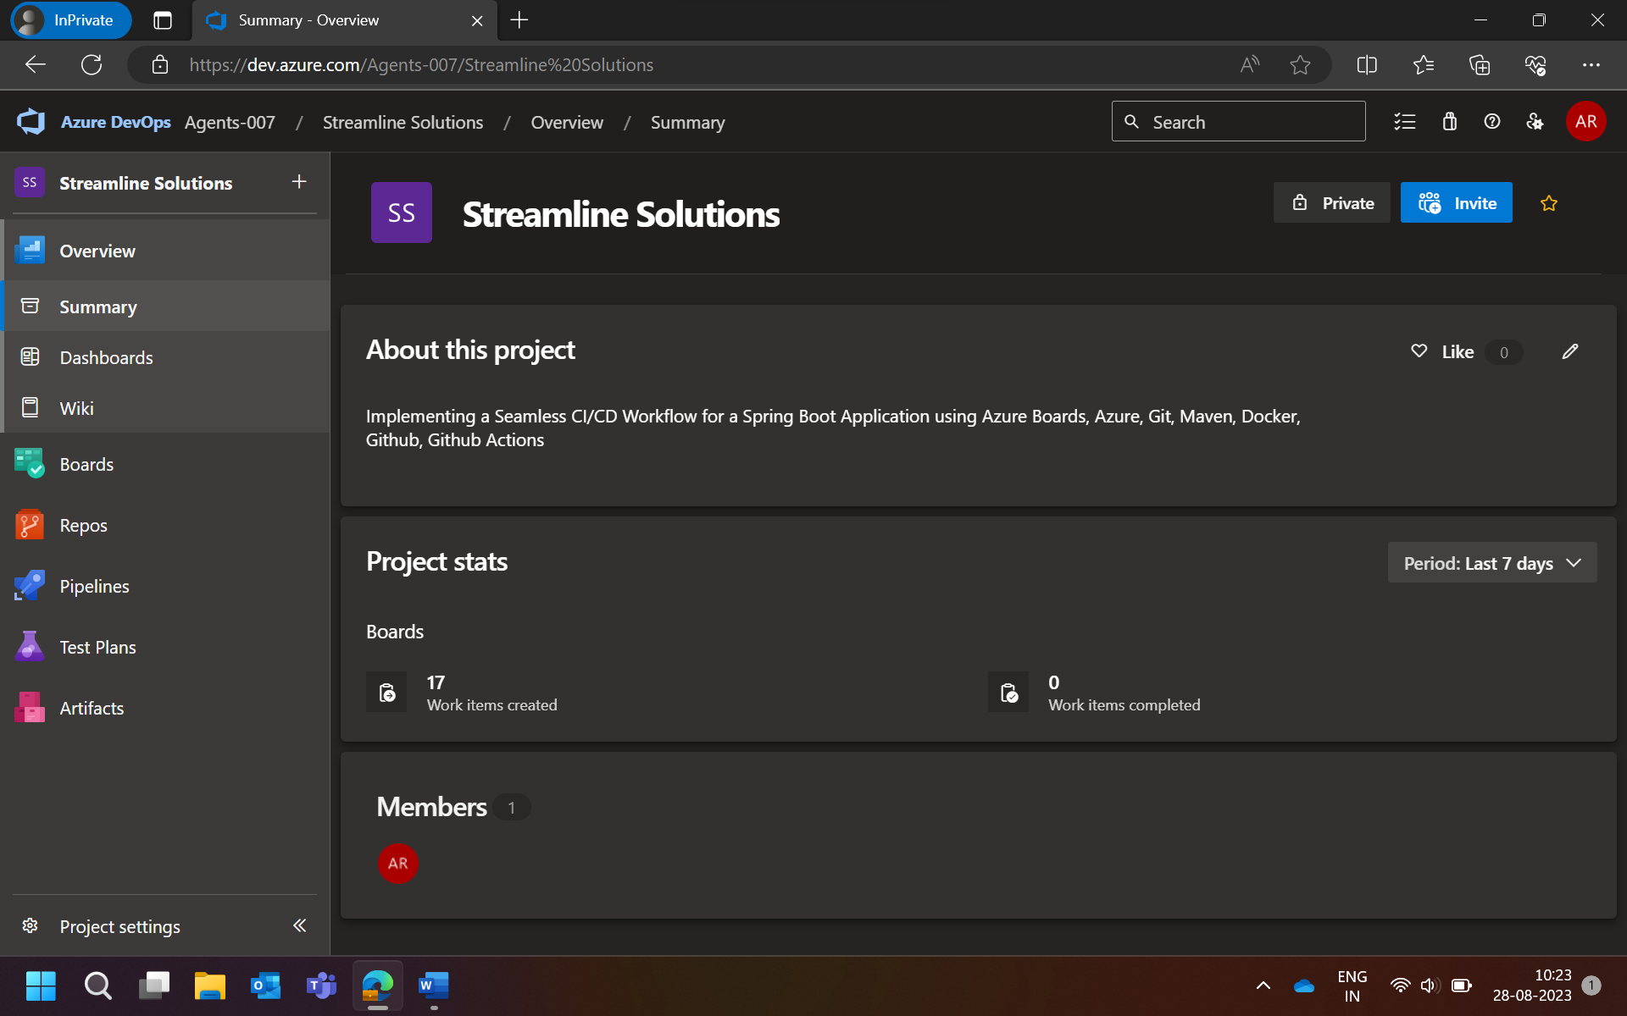

Step 2: Create Epic

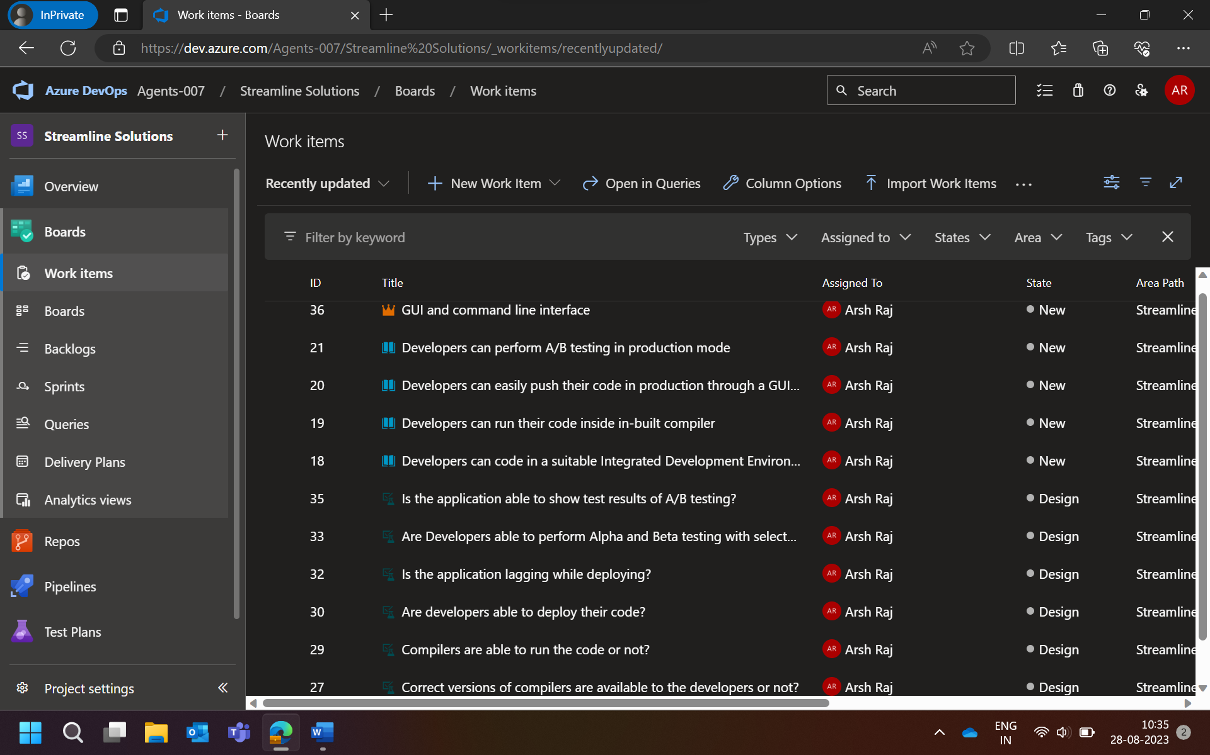

Step 3 : Creating Product Backlog , Sprint Backlog and User Stories

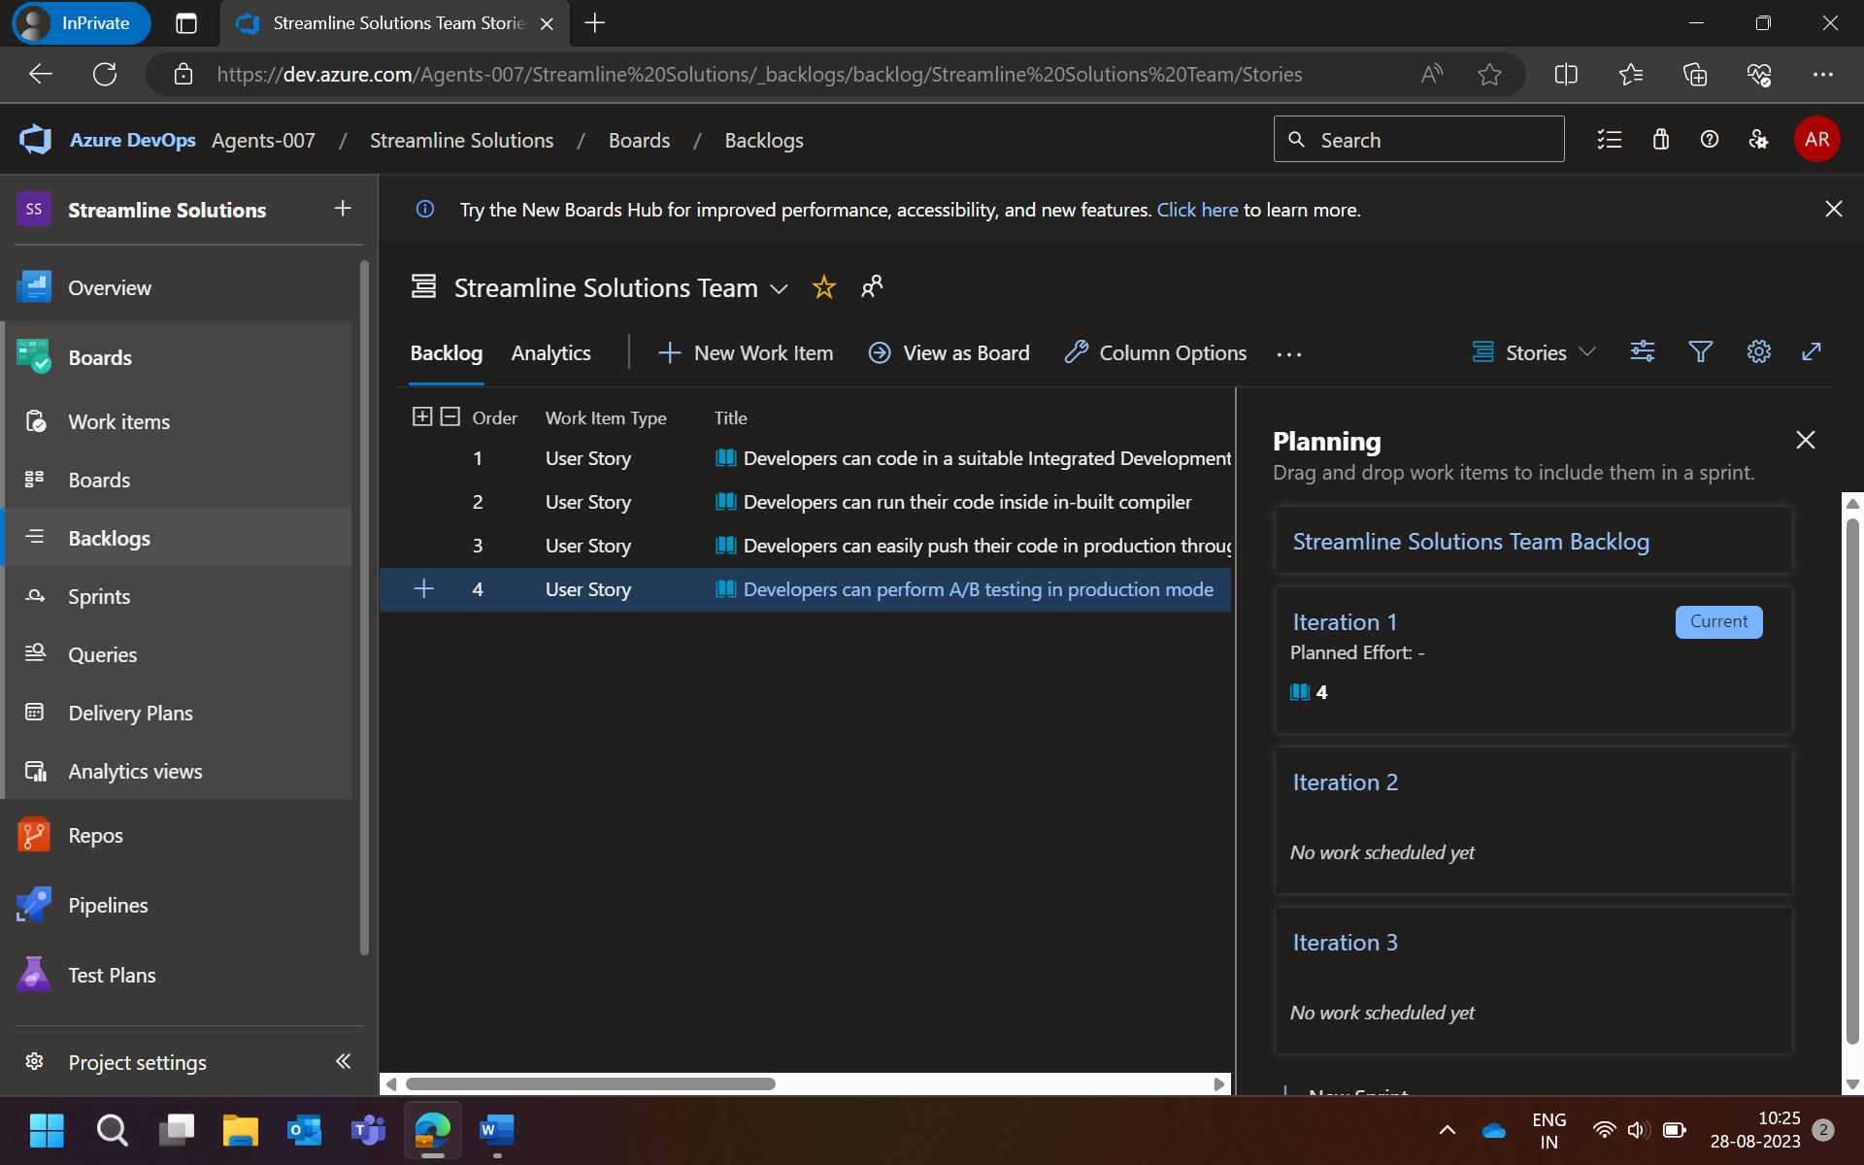

Step 4 : Create Tasks

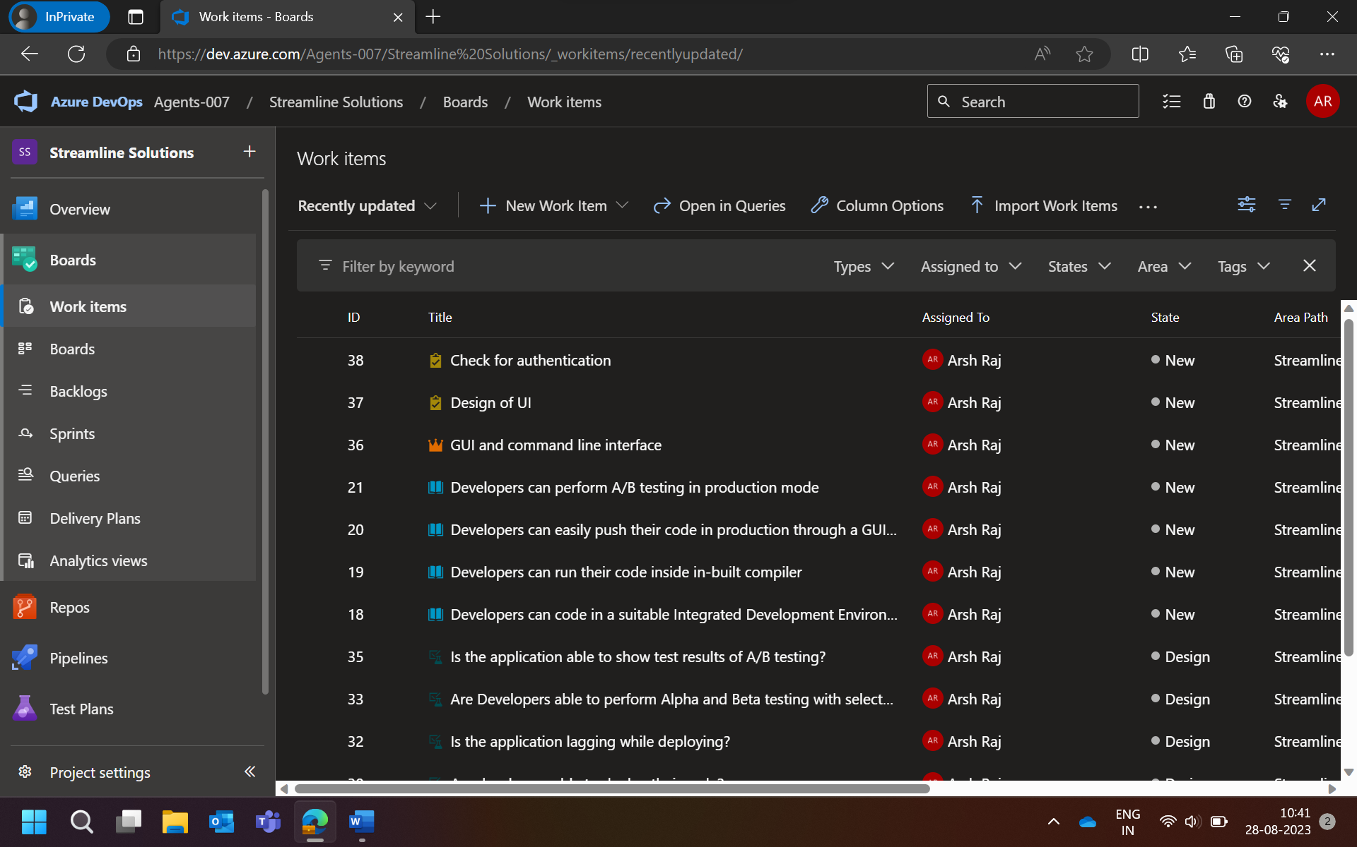

Step 5 : Create Test Cases and execute test cases(testing the output)

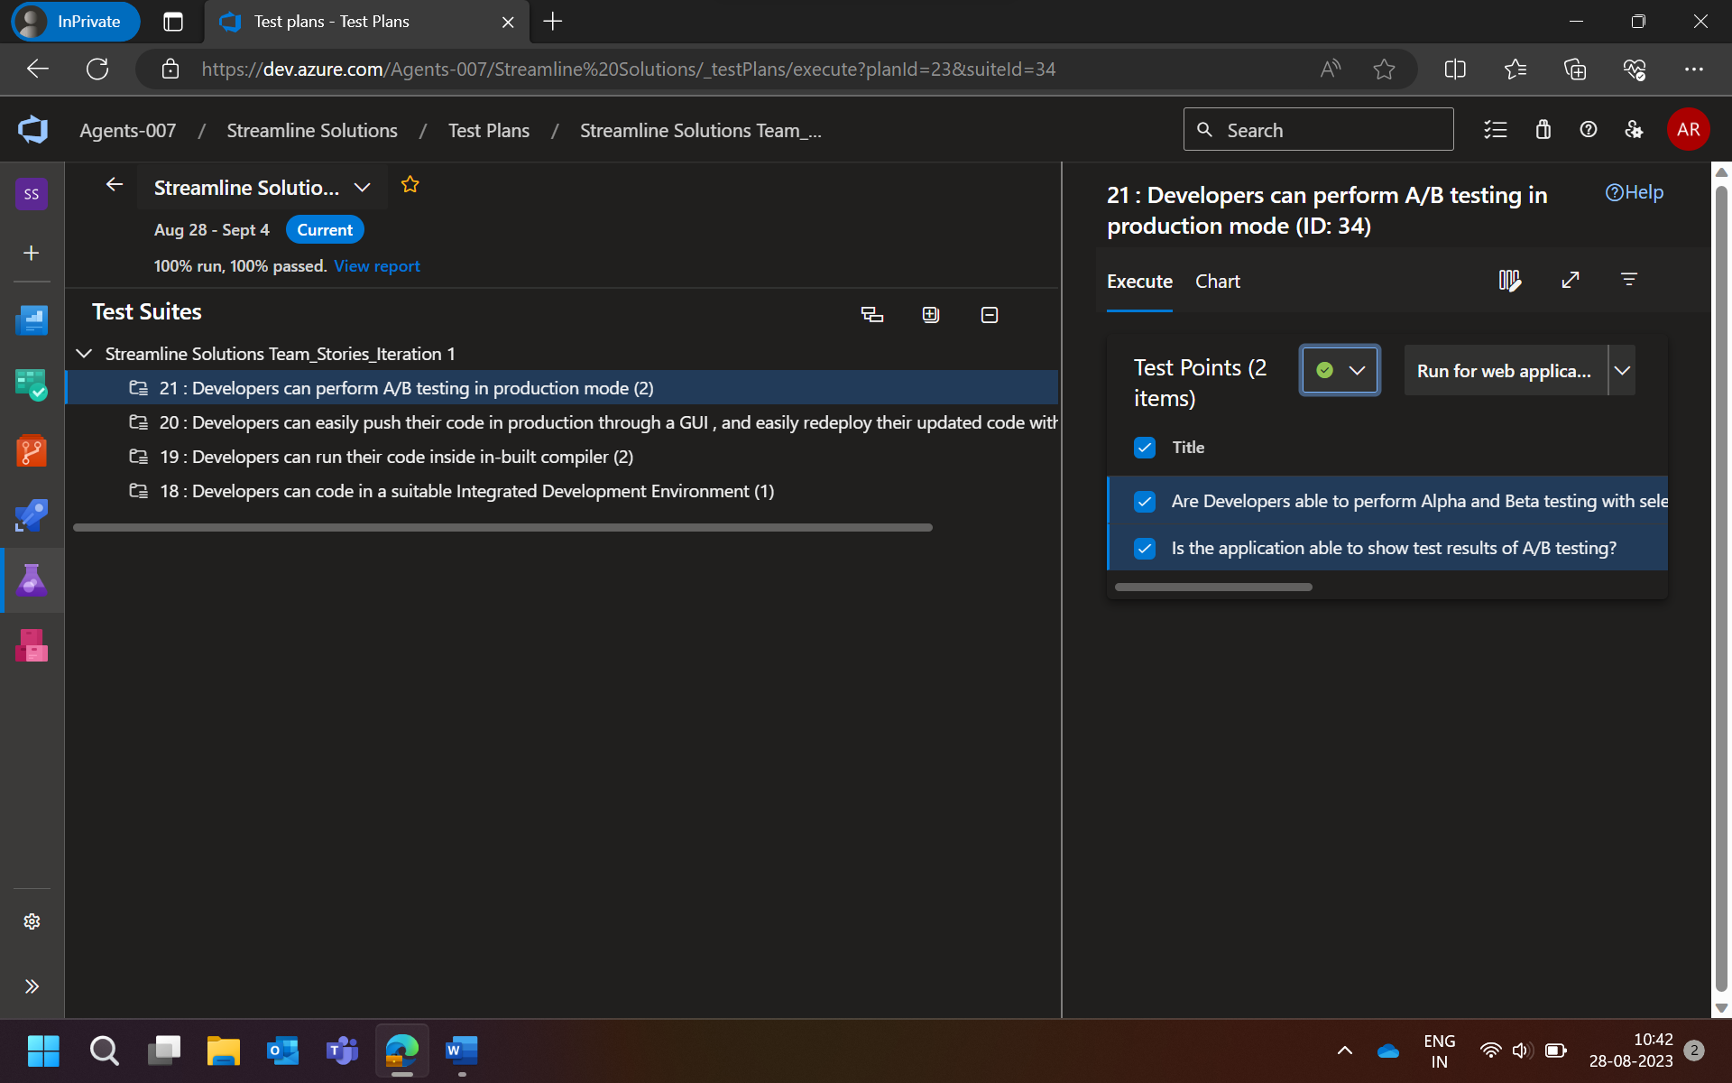

Step 6 : Create defect(Bugs)

